

**AN INTERNET OF THINGS (IoT) BASED SMART WASTE BIN MONITORING SYSTEM**

**BY**

**ODEY NICHOLAS TOCHUKWU**

**ENG1503588**

**UNIVERSITY OF BENIN**

**BENIN CITY**

**DECEMBER, 2020**

**A PROJECT SUBMITTED IN PARTIAL FULFILLMENT OF**

**THE REQUIREMENT FOR THE AWARD OF BACHELOR**

**OF ENGINEERING(B.ENG)**

**IN**

**THE DEPARTMENT OF COMPUTER ENGINEERING**

**FACULTY OF ENGINEERING, UNIVERSITY OF BENIN,**

**BENIN CITY.**

**SUPERVISED BY**

**ENGR. (DR). MRS KACHIKWU ERAMEH**

**AUGUST, 2020**

# CERTIFICATION

This is to certify that this project work was carried out by Odey Nicholas Tochukwu, with matriculation number ENG1503588, of the department of Computer Engineering, University of Benin, Benin City, Edo State, Nigeria.

Dr. ERAMEH K.

(PROJECT SUPERVISOR) DATE

ENGR. (DR.) U. I. IRUANSI

(HEAD OF DEPARTMENT) DATE

# DEDICATION

I, Odey Nicholas Tochukwu, dedicate this project report to God Almighty, my ultimate source of strength throughout the course of my project work, to my wonderful parents, Mr. and Mrs. Odey, for their unconditional love and support, to my siblings, friends, all the ghetto kids dreaming of making something for themselves, and Frank Ocean for his wonderful music, as well as to my project supervisor for her unquantifiable guidance and contributions.

# DECLARATION

Before the prestigious citadel of learning University of Benin, this great faculty of engineering and formidable department of computer engineering, I hereby assert that this project work is a product of personal research and the application of engineering skills.

Odey Nicholas Tochukwu

ENG1503588 Date

# ACKNOWLEDGEMENT

This entire project would not have been possible without the assistance, encouragement, support, and supervision of people I hold in high regard.

I would like to thank my project supervisor, Dr. Kachikwu Erameh, for the opportunity to conduct this research, for her guidance throughout the period, as well as for her patience during the course of this project, my course adviser, all members of the faculty, and all of my colleagues, friends, and family for their contributions.

# ABSTRACT

The goal of this project is to create an IoT (Internet of Things)-based ‘Smart Waste Bin Monitoring System.' The main contribution of this work is the use of a mobile phone to monitor the level of garbage and the odor inside the waste bin (GSM SYSTEM). The problem with today's waste disposal is that they have to inspect all waste containers to see if they are full or not. As a result, the amount of time it takes to empty out the garbage cans grows. When the waste bin is full, an alert is sent to the cleaner's phone.

The ATMega328P microcontroller is the brain of this project. The GSM (GPRS) module will be utilized to exchange data between the smart waste bins and their users (cleaners, end users). The principal sensor in this smart trash bin is an ultrasonic sensor that detects the distance between the garbage and the waste bin, as well as the distance between the waste cleaner and the waste bin. This smart waste bin also has a MQ135 sensor that detects bad odor in the waste bin.

This result includes three readings: 0%, 50%, and 100%. The garbage distance from the ultrasonic sensor must be greater than 10cm in order to achieve a 0% result. To achieve a 50% success rate, the garbage distance from the ultrasonic sensor must be greater than or equal to 5cm but less than 10cm. Finally, the garbage distance from the ultrasonic sensor must be less than 5cm for a perfect result. The economic importance of this result is of numerous forms as it aims to put a stop to the widespread issue of pollution in our neighboring environment, and automate the process of waste disposal

Contents

CERTIFICATION 2

DEDICATION 3

DECLARATION 4

ACKNOWLEDGEMENT 5

ABSTRACT 6

CHAPTER ONE 16

1.1 BACKGROUND OF THE STUDY 16

1.2 PROBLEM STATEMENT 18

1.3 AIM AND OBJECTIVES 18

**1.3.1 AIM** 18

**1.3.2 OBJECTIVES** 18

1.3.3 METHODOLOGY 19

1.4 SCOPE OF THE STUDY 19

1.5 RELEVANCE OF STUDY 19

1.6 OUTLINE OF THE REPORT 20

CHAPTER TWO 21

LITERATURE REVIEW 21

**2.1 INTERNET OF THINGS (IOT)** 21

**2.1.2 History of IoT** 21

**2.1.3 How IoT works** 24

**2.1.4 Why IoT is important** 24

**2.1.5 IoT benefits** 25

**2.1.6 Pros and cons of IoT** 26

**2.1.7 IoT standards and frameworks** 27

**2.1.8 IoT frameworks include the following:** 28

**2.1.9 Consumer and enterprise IoT applications** 28

**2.1.10 IoT security and privacy issues** 29

**2.1.11 Basic IoT concepts and terms** 30

**2.1.12 Specific types of IoT and its applications:** 30

2.2 DEFINITION OF COMPONENTS 31

**2.2.1** **ATMEGA328P MICROCONTROLLERS** 31

**2.2.1.2 ATMega328 Pin Configuration** 31

**2.2.1.3 Features** 34

**2.2.1.4 Where to Use ATMEGA328P** 36

**2.2.1.5 How to Use ATMEGA328P** 37

**2.2.1.6 Applications** 37

**2.2.2** **ULTRASONIC SENSOR** 38

**2.2.2.1 How Ultrasonic Sensors Work.** 38

**2.2.2.2 How are Ultrasonic Sensors used** 38

**2.2.2.3 When Not to Use an Ultrasonic Sensor** 39

**2.2.2.4 Using Your Ultrasonic Sensor in Your Project** 39

**2.2.2.5 Why use an Ultrasonic Sensor** 39

**2.2.3** **GSM/GPRS MODULE** 41

**2.2.3.1 GSM History** 42

**2.2.3.2GSM Architecture** 42

**2.2.3.3 How GSM communication works** 45

**2.2.3.4 GSM/GPRS Module** 45

**2.2.3.5 Features of GSM Module** 46

**2.2.4** **SERVO MOTOR** 47

**2.2.4.1 Servo Motor Working Mechanism** 47

**2.2.4.2 Interfacing Servo Motors with Microcontrollers** 48

**2.2.4.3 Advantages:** 48

**2.2.4.4 Disadvantages:** 48

**2.2.4.5 Applications of Servo Motors** 49

**2.2.5 MQ135 SENSOR** 50

**2.2.5.1 Basic Pin Configuration of Alcohol Sensor** 50

**2.2.5.2 Working Principle and Circuit Diagram** 50

**2.2.5.3 MQ – 135 Air Quality Sensor** 51

**2.2.5.4 Applications of MQ 135 Gas Sensor** 52

**2.2.5.5 Characteristics of MQ 135** 52

**2.2.6 WEB DEVELOPMENT** 52

**2.2.6.1 Cloud/Web Based Application** 53

**2.2.4.6 Models Of Web Application Components** 56

**2.2.4.7 Theory of Web Technology Used** 57

**2.2.4.8 Web Technologies Used** 58

**2.2.4.9 Development Environment** 59

**2.2.5 DC to DC Converter** 61

**2.2.5.1 DC to DC Converter Operating Principle and Functionality** 61

**2.2.5.2 DC to DC Buck Boost Converter** 62

**2.2.5.3 What is a Buck Boost Converter?** 62

**2.2.5.4 Working principle of Buck-Boost Converter** 63

**2.2.5.5 Modes of Buck Boost Converters** 65

**2.2.5.6 Applications of Buck boost converter** 65

**2.2.5.7 Advantages of Buck Boost Converter** 65

**2.2.5** **RELATED WORKS** 65

CHAPTER 3 68

METHODOLOGY 68

**3.0 Introduction** 68

**3.1 GSM Module** 68

**3.2 General Packet Radio Services** 69

**3.8 Flowchart of the system.** 73

**3.8.1 Development Environment** **Error! Bookmark not defined.**

**3.8.2 Program Structure** 74

**3.9 Construction and Packaging** 78

**3.9.1 Construction Techniques** 78

**3.9.2** **Materials/Components Used In The Construction** 79

**3.9.3** **Casing and Packaging Material** 80

CHAPTER 4 82

TESTING AND RESULT 82

**4.1 TESTING** 82

**4.1.1 Functionality Testing** 82

**4.1.2 Performance Testing** 82

**4.1.3 User Acceptance Testing** 82

**4.1.4 Application Testing** 83

**4.2 TESTING SCREENSHOTS** 83

**4.3 RESULT** 87

**4.2 BILL OF ENGINEERING MEASUREMENT AND EVALUATION (BEME).** 87

CHAPTER 5 89

CONCUSION AND RECOMMENDATION 89

**5.1 CONCLUSION** 89

**5.2 RECOMMENDATION** 89

REFRENCES 90

LIST OF FIGURES

Figure 1-ATMega328P Microcontroller 37

Figure 2-Ultrasonic working diagram 40

Figure 3-Ultrasonic Sensor 41

Figure 4-The base station subsystem 43

Figure 5-GSM module 46

Figure 6-Servo Motor 49

Figure 7-MQ-135 Gas Sensor 50

Figure 8-Pin Configuration of Alcohol Sensor 50

Figure 9-MQ-135 Circuit Diagram 51

Figure 10-MQ – 135 Air Quality Sensor 51

Figure 11-Block diagram of data movement in the System 61

Figure 12-Buck Boost Converter 63

Figure 13-Buck Converter Working 63

Figure 14-Boost Converter Working 64

Figure 15-Block Diagram 68

Figure 16-GSM setup 68

Figure 17-ATMEGA328P setup 71

Figure 18-Web movement diagram 72

Figure 19-Flowchart of the system 73

Figure 20-Web Interaction 75

Figure 21-Backend code 75

Figure 22-Front end code 76

Figure 23-index code 76

Figure 24-dashboard code 77

Figure 25-Login Page code 77

Figure 26-Universal programmer 78

Figure 27-Circuit Diagram 79

Figure 28-Circuit on Vero board 79

Figure 29-Packaged system 81

Figure 30-System at 0% waste 83

Figure 31-System at 25% waste 84

Figure 32-System at 50% waste 84

Figure 33-System at 75% waste 85

Figure 34-System at 100% waste 85

Figure 35-System showing foul odor detected 86

Figure 36-Alert from web platform 86

LIST OF TABLES

Table 1-ATMEGA328P pin configurations Error! Bookmark not defined.

Table 2-ATMEGA328P features Error! Bookmark not defined.

Table 3-proposed bill of engineering measurement and evaluation (beme). Error! Bookmark not defined.

# CHAPTER ONE

# 1.1 BACKGROUND OF THE STUDY

The Internet of Things (IoT) is a network of interconnected, internet-connected objects that can collect and transfer data over a wireless network without the need for human intervention (What is IoT? Defining the Internet of Things (IoT) in 2021. The internet of Things, or “IoT,” refers to the process of extending the power of the internet beyond computers and smartphones to a wide range of other things, processes, and environments. Those "connected" things collect data, send data back, or do both (Callum McClelland, 2020).

Today, companies are motivated by IoT and its revenue growth prospects, operational cost reduction and efficiency improvement. No matter why, IoT Device deployments provide the information and insights needed for streamlining workflows, visualizing usage patterns, automating processes and meeting compliance requirements in a changing business environment, as well as competing more efficiently (What is IoT? Defining Things' Internet (IoT), 2021). IoT provides better insight and control for businesses and people over 99% of objects and environments beyond the reach of the Internet. In doing that, IoT allows companies and people to have a more meaningful and higher level of work connected with the world around them (Callum McClelland, 2020). An IoT system includes sensors that "refer" to the cloud using certain connectivity devices. When the data reaches the cloud, software processes it and then decides whether it needs to be done or not without human input.

In works such as asset tracking, energy efficiency, agricultural efficiency, inventory management, improved health and safety, enforcement and waste management IoT based systems find applications (Callum McClelland, 2020).

Waste is a substance that is discarded or worthless, defective and useless, after primary use. They are categorized as solid waste and wet waste, depending on their physical condition. The scene of cleanliness in waste management has become crucial with the proliferation of the population. Waste management includes waste planning, recovery, transport, treatment, recycling and disposal, monitoring, and regulation. waste management (Mahajan et al., 2017). The existing waste management system, in which waste from streets, homes and other facilities is collected on a daily basis, cannot manage waste effectively.

Waste bin is the waste disposal container used by everybody in the world. It is the principal thing that people look for in their environment for waste disposal. Intelligent waste bin is a special type of waste disposable bin; the smart term derives from its integration in some components to increase the efficiency of use of this hardware. Including some hardware components like ATMEGA328P, GSM module, Servo Motor, Ultrasonic Sensors, smart waste bin.

The universal truth is that it is damaging for society to waste anything. The ultimate necessity of developing countries is key to 'smart cities,' which can include hazardous pollution, health effects etc. (Shubhangi, Swati & Pooja, 2019). The Internet of Things (IOT) therefore offers new ways of making cities intelligent with the introduction of an intelligent waste management system. We are making a significant move forward into a smart city, we have fewer waste baskets in cities, all types of waste are dispersed and dumped together, overflowing and uncontrolled by local authorities (Shubangi et al., 2019). The project develops a new concept of waste disposal using an automatic waste level and ultrasound sensor and a sensor MQ135 for odor detection and will provide realtime information on waste containers in the city. When the waste bin is filled or an odor is detected, the relevant authority or persons shall receive this information to clean the waste bin on a website which is already built. I use GSM for real time data. GSM is now the back of communication systems, a low-cost, high-performance and easy-to-implement device. When the dustbin is filled out, the GSM module provides a message to the cloud, reads the cloud message and interprets it in the form of an alert message to the user.

When this project comes to an end, we will save time, money and fuel efficiently and provide accurate and detailed information to cleaners as regards the efficacy of waste and municipal waste disposal patterns, as well as reduce emissions of exhaust gas and provide more access to a safe and efficient waste bin.

# 1.2 PROBLEM STATEMENT

Today, in the quick urbanization area, there are tons of apartments. This is because of a high demand for housing, which has risen drastically because people migrate from villages to towns to find work. The government also constructed more apartment complexes to accommodate the growing population in urban areas (Aasim, Prateek, Rajeshwar, & Sadiq, 2018).

There are several issues faced by the residents of these flats. One of them is disposal of solid waste. Unlike private houses, the residents of all the apartments use a common waste bin, which tends to fill up very quickly. This overflow of garbage is a sanitary issue which might cause diseases like cholera, diarrhea and dengue fever (Aasim et al., 2018). Moreover, it is a waste of fuel to travel around a complex or an area to find that some of the waste bins are filled and some are not. Also, on rare days, problems might arise that there is so much garbage that the truck doesn’t have enough capacity.

The idea struck me when I saw the trash truck passing around the city collecting solid waste 2 times a day. This system was very ineffective although it was thorough. For example, let's say street A is a busy street, and we can see the garbage filling up very quickly while street B may not even be half full after two days. This example brought me to the moment "Eureka!"

The above mentioned problems are recurring and unsolved, so I have developed an IoT-based intelligent waste monitoring system to correct the situation.

# 1.3 AIM AND OBJECTIVES

## **1.3.1 AIM**

The aim of this project is to build and design a prototype of a smart waste management monitoring system

## **1.3.2 OBJECTIVES**

* To design the IoT – based ‘Smart Waste Monitoring System
* To interface Ultrasonic and MQ135 sensors with an ATMega328P microcontroller.
* To interface GSM Module to an ATMega328P microcontroller.
* To upload the contents of the microcontroller readings to a server
* To build a website
* To notify the cleaner about the garbage level of the waste bin and its precise location.
* To render the fetched/stored data cognitively over a website

# 1.3.3 METHODOLOGY

The methods used in the design and execution of this project include the design of the control circuit, which is central to the system's operation. The control circuit is simply the manner in which the system is organized and viewed in its main components. It describes how these components interact in order to achieve the total system objective. The system flow chart is also designed; it shows the system flux from starting a task until finishing the task. The flow chart shows the system's different output as a response to the different inputs.

# 1.4 SCOPE OF THE STUDY

The prototype for this project is primarily responsible for monitoring the waste in the trash basket. The status of the waste bin is cognitively reported on a website, where it can be accessed from any distant location or device with internet access, and where the data displayed on the website show the waste bin level, and when the waste bin is fully loaded notify the person in charge.

# 1.5 RELEVANCE OF STUDY

This study is applied in different life areas. In truth, every industry known to humans produces waste. This project helps to better improve waste management for waste disposal companies. It makes access to the trash bin easy and remote. The project can be used to support sanitation and efficiencies of waste management by industries such as the chemical, agricultural and health sectors, etc.

# 1.6 OUTLINE OF THE REPORT

* The first chapter introduces the thesis as it relates to the subject matter “AN INTERNET OF THINGS (IoT) BASED SMART WASTE BIN MONITORING SYSTEM”. It also gives information on the Background Study, Problem Statement, Aim and Objectives, Methodology, Scope as well as the Relevance of the Study.
* The second chapter emphasizes on the literatures that were reviewed during this research, discussing related works and the in-depth explanation of written documentation on tools and theories to be used during this study.
* The third chapter contains the Methodology, it includes the methods used to achieve the aim and objectives and also how this project was carried out, which may include block diagrams.
* Chapter four talks about results obtained which will include test(s), procedure(s), observation(s) and result(s) during the research. This chapter also includes the Bill of Engineering Measurement and Evaluation (BEME).
* Lastly, chapter five brings us to the summary of the work which includes conclusion, limitation, recommendation, it also reveals if the aim and objectives I set out to achieve were realized.

# CHAPTER TWO

# LITERATURE REVIEW

## **2.1 INTERNET OF THINGS (IOT)**

The internet of things (IoT) is a network of interconnected computing devices, mechanical and digital machines, objects, animals, or people that have unique identifiers (UIDs) and the ability to transfer data over a network without the need for human-to-human or human-to-computer interaction.

A thing in the internet of things can be a person implanted with a heart monitor, a farm animal implanted with a biochip transponder, a car with built-in sensors to alert the driver when tire pressure is low, or any other natural or man-made object that can be assigned an Internet Protocol (IP) address and can transfer data over a network.

Organizations in a variety of industries are increasingly utilizing IoT to operate more efficiently, better understand customers in order to provide enhanced customer service, improve decision-making, and increase business value.

### **2.1.2 History of IoT**

The internet of things was first mentioned by Kevin Ashton, co-founder of the Auto-ID Center at the Massachusetts Institute of Technology (MIT), in a 1999 presentation to Procter & Gamble (P&G). To draw the attention of P&G's senior management to radio frequency identification (RFID), Ashton titled his presentation "Internet of Things" to incorporate the cool new trend of 1999: the internet. When Things Start to Think, a book by MIT professor Neil Gershenfeld, was also published in 1999. It didn't use the exact term, but it did provide a clear vision of where IoT was going.

The Internet of Things (IoT) emerged from the convergence of wireless technologies, microelectromechanical systems (MEMS), microservices, and the internet. The convergence has aided in the dismantling of silos between operational technology (OT) and information technology (IT), allowing unstructured machine-generated data to be analyzed for insights that can be used to drive improvements.

Although Ashton's was the first mention of the internet of things, the concept of connected devices has existed since the 1970s, under the names embedded internet and pervasive computing.

In the early 1980s, the first internet appliance was a Coke machine at Carnegie Mellon University. Programmers could use the web to check the status of the machine and see if there was a cold drink waiting for them if they decided to go to the machine.

IoT evolved from machine-to-machine (M2M) communication, which involved machines communicating with one another over a network without the need for human intervention. Connecting a device to the cloud, managing it, and collecting data is referred to as M2M.

IoT is a sensor network of billions of smart devices that connect people, systems, and other applications to collect and share data, taking M2M to the next level. M2M serves as the foundation for IoT by providing connectivity.

The internet of things is also a natural extension of supervisory control and data acquisition (SCADA), a category of software application programs for process control that gather real-time data from remote locations to control equipment and conditions. SCADA systems are made up of both hardware and software. The hardware collects and feeds data into a computer running SCADA software, where it is processed and displayed in real time. SCADA has evolved to the point where late-generation SCADA systems have evolved into first-generation IoT systems.

The concept of the IoT ecosystem, on the other hand, didn't really come into its own until the middle of 2010, when the Chinese government announced, in part, that it would make IoT a strategic priority in its five-year plan.

As home internet became more common and Wi-Fi speeds increased, the dream of the smart home began to take shape. Companies began to introduce an increasing number of IoT inventions, such as "smart" coffee makers that brew the perfect cup, ovens that bake cookies with precise timing, and refrigerators that automatically restocked expired milk. LG's internet-connected refrigerator was the first to hit the market in 2000. It could count the contents of the shelves, keep track of expiration dates, and, for some reason, came with an MP3 player. It also cost $20,000 to build. As sensors became more affordable, these internet-connected devices became more accessible to a wider range of consumers. And the invention of smart plugs, such as those made by Belkin, meant that even ordinary objects could become "smart"—or, at the very least, you could turn them on and off with your phone.

Any IoT system today is made up of a few basic components. First, there's the sensor-equipped device. These sensors could be anything that collects data, such as a camera embedded in a smart refrigerator or an accelerometer in a smart running shoe. In some cases, sensors are combined to collect multiple data points: A Nest thermostat includes a thermometer as well as a motion sensor; it can adjust the temperature of a room if it detects that no one is in it. To make sense of this data, the device has network connectivity (Wi-Fi, Bluetooth, cellular, or satellite) and a processor where it can be saved and analyzed. The data can then be used to trigger an action, such as ordering more milk when the carton in the smart fridge runs out, or automatically adjusting the temperature based on a set of rules.

Most people did not begin to build an ecosystem of "smart" devices in their homes until voice controls became widely available. Amazon released the Echo, a speaker with a built-in voice assistant named Alexa, in 2014. Apple had introduced Siri, its own voice assistant, four years prior—but Siri lived on your phone, whereas Alexa lived inside the speaker and could control all of your home's "smart" devices. Positioning a voice assistant as the smart home's centerpiece had several effects: It demystified the internet of things for consumers, encouraged them to purchase more internet-connected devices, and encouraged developers to create more "skills," or IoT commands, for these voice assistants to learn.

The same year that Amazon introduced Alexa, Apple released HomeKit, a system designed to facilitate interactions between Apple-made smart devices by sending data back and forth to form a network. These unified voices have shifted the landscape away from single-purpose automations and toward a more holistic network of interconnected things. If you say "goodnight" to Google Assistant, it will dim the lights, lock the front door, set the alarm system, and turn on your alarm clock. LG's SmartThinQ platform connects many home appliances, so you can choose a chocolate chip cookie recipe from your smart fridge's screen and it will automatically preheat the oven. Manufacturers market this as the future, but it's also a convenient way for them to sell more IoT devices. If you already have an Amazon Echo, you might as well get some Alexa-controllable items.

By 2014, the number of internet-connected devices would outnumber people on the planet. Former Cisco chief futurist David Evans estimated in 2015 that “an average of 127 new things are connected to the internet” every second. According to Gartner estimates, there are over 20 billion connected things in the world today. The excitement surrounding the brave new internet-connected world has been tempered by apprehension. All of these objects, brought to life like Pinocchio, have helped to control the world: With a few taps on your smartphone, you can let the delivery man in or change the temperature inside the house. But it has also given our objects—and the companies that make them—more power over us.

### **2.1.3 How IoT works**

An IoT ecosystem consists of web-enabled smart devices that collect, send, and act on data collected from their environments using embedded systems such as processors, sensors, and communication hardware. IoT devices share sensor data by connecting to an IoT gateway or other edge device, from which data is either sent to the cloud for analysis or analyzed locally. These devices occasionally communicate with other related devices and act on the information they receive from one another. The devices do the majority of the work without human intervention, though people can interact with them to set them up, give them instructions, or access data.

The connectivity, networking, and communication protocols used with these web-enabled devices are heavily influenced by the IoT applications that are deployed.

The Internet of Things (IoT) can also make use of artificial intelligence (AI) and machine learning to make data collection processes easier and more dynamic.

### **2.1.4 Why IoT is important**

The internet of things enables people to live and work more intelligently, as well as gain complete control over their lives. IoT is essential to business in addition to providing smart devices for home automation. The Internet of Things (IoT) gives businesses a real-time view of how their systems actually work, providing insights into everything from machine performance to supply chain and logistics operations.

The Internet of Things enables businesses to automate processes and reduce labor costs. It also reduces waste and improves service delivery, lowering the cost of manufacturing and delivering goods while also providing transparency into customer transactions.

As a result, IoT is one of the most important technologies in everyday life, and it will gain traction as more businesses recognize the potential of connected devices to keep them competitive.

### **2.1.5 IoT benefits**

Organizations and everyday life can benefit from the internet of things in a variety of ways. Some benefits are industry-specific, while others apply to multiple industries. Some of the most common advantages of IoT enable businesses to:

* monitor their overall business processes
* improve the customer experience (CX)
* save time and money
* enhance employee productivity
* integrate and adapt business models
* make better business decisions, and
* generate more revenue.

IoT encourages businesses to rethink their business approaches and provides them with the tools to improve their business strategies.

For consumers, the main advantage of IoT is convenience and ease of use. As the Internet of Things expands and permeates the public sphere, more tangible and social benefits will emerge, including:

* Environmental decisions that are more informed as a result of greater understanding of our impact on the environment, pollution, and so on.
* Smart cities that transform the way urban environments operate.
* • As a result of these events, observe changes in culture and politics. The massive amount of data generated by IoT networks and smart cities will provide people with new insights into areas that were previously restricted by the amount of real-time data available. Implementing a location-free voting system and combining biometric voter registration and authentication with IoT to ease voting and increase security are two examples of how this is affecting politics.

In general, IoT is most prevalent in manufacturing, transportation, and utility organizations, where sensors and other IoT devices are used; however, it has also found applications in agriculture, healthcare, waste management, infrastructure, and home automation, leading some organizations toward digital transformation.

Farmers can benefit from IoT by making their jobs easier. Sensors can collect data on rainfall, humidity, temperature, and soil content, among other things, to aid in the automation of farming techniques.

The ability to monitor infrastructure operations is another factor that IoT can help with. Sensors, for example, could be used to track events or changes in structures such as buildings, bridges, and other infrastructure. This has a number of advantages, including cost savings, time savings, workflow changes that improve quality of life, and paperless workflow.

IoT can be used by a home automation company to monitor and control a building's mechanical and electrical systems. Smart cities can help citizens reduce waste and energy consumption on a larger scale.

The Internet of Things has an impact on every industry, including healthcare, finance, retail, and manufacturing.

### **2.1.6 Pros and cons of IoT**

Some of the advantages of IoT include the following:

* access to information from any location, at any time, and on any device;
* improved communication among electronic devices that are connected;
* saving time and money by transferring data packets over a network; and
* task automation assisting in the improvement of a business's services and reducing the need for human intervention.

Some disadvantages of IoT include the following:

* The possibility of a hacker stealing confidential information increases as the number of connected devices increases and more information is shared between devices.
* Enterprises may eventually have to deal with massive numbers of IoT devices, possibly even millions, and collecting and managing data from all of those devices will be difficult.
* If the system contains a bug, every connected device will most likely become corrupted.
* It is difficult for devices from different manufacturers to communicate with each other because there is no international standard of compatibility for IoT.

### **2.1.7 IoT standards and frameworks**

There are several emerging IoT standards, including the following:

* The Internet Engineering Task Force has defined IPv6 over Low-Power Wireless Personal Area Networks (6LoWPAN) as an open standard (IETF). The 6LoWPAN standard allows any low-power radio, such as 804.15.4, Bluetooth Low Energy (BLE), and Z-Wave, to communicate with the internet (for home automation).
* • ZigBee is a low-power, low-data-rate wireless network that is mostly used in industrial applications. The ZigBee protocol is based on the IEEE 802.15.4 standard. Dotdot, the universal language for IoT created by the ZigBee Alliance, allows smart objects to communicate and work securely on any network.
* LiteOS is a wireless sensor network operating system (OS) based on Unix. Smartphones, wearables, intelligent manufacturing applications, smart homes, and the internet of vehicles are all supported by LiteOS (IoV). The operating system also serves as a platform for developing smart devices.
* To connect devices, OneM2M is a machine-to-machine service layer that can be embedded in software and hardware. OneM2M, a global standardization body, was established to create reusable standards that would allow IoT applications from various industries to communicate with one another.
* The Object Management Group (OMG) created the Data Distribution Service (DDS), which is an IoT standard for real-time, scalable, and high-performance M2M communication.
* The Advanced Message Queuing Protocol (AMQP) is a published open source standard for asynchronous messaging over the wire. AMQP allows organizations and applications to communicate in an encrypted and interoperable manner. The protocol is used in client-server messaging as well as the management of IoT devices.
* The IETF's Constrained Application Protocol (CoAP) specifies how low-power, compute-constrained devices can operate in the internet of things.
* Long Range Wide Area Network (LoRaWAN) is a WAN protocol designed to support massive networks with millions of low-power devices, such as smart cities..

### **2.1.8 IoT frameworks include the following:**

* Amazon Web Services (AWS) IoT is Amazon's cloud computing platform for IoT. This framework is intended to allow smart devices to connect to and interact with the AWS cloud and other connected devices in a simple and secure manner.
* Arm Mbed IoT is an IoT app development platform based on Arm microcontrollers. By integrating Mbed tools and services, the Arm Mbed IoT platform aims to provide a scalable, connected, and secure environment for IoT devices.
* The Azure IoT Suite from Microsoft is a platform that consists of a set of services that allows users to interact with and receive data from their IoT devices, as well as perform various operations over data, such as multidimensional analysis, transformation, and aggregation, and visualize those operations in a business-friendly manner.
* Brillo/Weave by Google is a platform for the rapid development of IoT applications. Brillo, an Android-based OS for the development of embedded low-power devices, and Weave, an IoT-oriented communication protocol that serves as the communication language between the device and the cloud, form the platform's two main backbones.
* Calvin is an open source IoT platform developed by Ericsson that allows for the creation and management of distributed applications that allow devices to communicate with one another. Calvin includes a development framework for application developers as well as a runtime environment for dealing with running applications.

### **2.1.9 Consumer and enterprise IoT applications**

The internet of things has a wide range of real-world applications, from consumer IoT and enterprise IoT to manufacturing and industrial IoT. (IIoT). Automotive, telecommunications, and energy are just a few of the industries that use IoT.

Smart homes, for example, equipped with smart thermostats, smart appliances, and connected heating, lighting, and electronic devices, can be controlled remotely via computers and smartphones in the consumer segment.

Wearable devices equipped with sensors and software can collect and analyze user data, sending messages about the users to other technologies in order to make their lives easier and more comfortable. Wearable devices are also used in public safety, such as improving first responder response times during emergencies by providing optimized routes to a location or tracking construction workers' or firefighters' vital signs at potentially hazardous locations.

In healthcare, IoT provides numerous advantages, including the ability to more closely monitor patients through data analysis. IoT systems are frequently used in hospitals to complete tasks such as inventory management for pharmaceuticals and medical instruments.

Smart buildings, for example, can reduce energy costs by using sensors that detect how many people are in a room. The temperature can be adjusted automatically, such as turning on the air conditioner if sensors detect that a conference room is full or turning down the heat if everyone in the office has gone home.

Smart farming systems based on IoT can help monitor crop fields' light, temperature, humidity, and soil moisture using connected sensors. IoT can also help with irrigation system automation.

IoT sensors and deployments, such as smart streetlights and smart meters, can help alleviate traffic, conserve energy, monitor and address environmental concerns, and improve sanitation in a smart city.

### **2.1.10 IoT security and privacy issues**

The internet of things connects billions of devices to the internet and involves the use of billions of data points, all of which must be secured. IoT security and privacy are cited as major concerns due to its expanded attack surface.

Mirai, a botnet that infiltrated domain name server provider Dyn and brought many websites down for an extended period of time in one of the largest distributed denial-of-service (DDoS) attacks ever seen, was one of the most notorious recent IoT attacks in 2016. Attackers gained network access by taking advantage of insecure IoT devices.

Because IoT devices are so closely linked, a hacker only needs to exploit one vulnerability to corrupt all of the data, rendering it useless. Manufacturers who fail to update their devices on a regular basis, if at all, leave them vulnerable to cybercriminals.

Furthermore, connected devices frequently prompt users to enter personal information such as names, ages, addresses, phone numbers, and even social media accounts – information that hackers can exploit.

Hackers aren't the only threat to the internet of things; IoT users' privacy is also a major concern. Companies that manufacture and sell consumer IoT devices, for example, could use those devices to collect and sell personal information from users.

Aside from leaking personal data, IoT poses a threat to critical infrastructure such as electricity, transportation, and financial services.

### **2.1.11 Basic IoT concepts and terms**

The four pillars of IoT and the key concepts to grasp are as follows:

**Data.** IoT technologies enable a plethora of methods for collecting data about the physical world. Data is the fuel that drives IoT, which is why it is so critical.

**Device.** The actual, physical components or things that collect this data in the internet of things.

**Analytics.** The process of making collected data useful by turning raw data into actionable insights The process of transforming raw data into actionable insights in order to make collected data useful.

**Connectivity.** Allows for the sharing of data and insights, increasing the data's value. This is the internet in the context of the Internet of Things.

### **2.1.12 Specific types of IoT and its applications:**

Industrial internet of things **(IIoT):** Refers to the use of IoT in industrial applications.

Internet of medical things **(IoMT):** The use of IoT in medicine.

V2X communications **(**[**vehicle to everything communications**](https://internetofthingsagenda.techtarget.com/tutorial/How-do-V2X-communications-help-connected-cars-share-information)**):** A vehicle's ability to sense its environment and communicate with it.

Internet of battlefield things**(IoBT):** When IoT is used for military purposes.

# 2.2 DEFINITION OF COMPONENTS

In this study, the different components that make up the smart waste management system are discussed ranging from the microcontroller used (ATMega328P) to the various sensors used.

## **2.2.1 ATMEGA328P MICROCONTROLLERS**

The ATmega328P is a high-performance AVR microcontroller with a large number of pins and features. It is built with 8-bit CMOS technology and an RSIC CPU, which improves its performance and power efficiency. It also has an internal temperature sensor and auto sleeps. This ATmega328P IC includes internal safeguards and multiple programming methods, allowing engineers to prioritize this controller for various situations. The IC enables multiple modern-era communications methods for other modules and microcontrollers, which is why the microcontroller ATmega328P is becoming more popular by the day.

### **2.2.1.2 ATMega328 Pin Configuration**

The ATMEGA328P is a 28-pin chip, as illustrated in the pin diagram above. Many of the chip's pins serve more than one purpose. The table below describes the functions of each pin.

Table 1. ATMEGA328P pin configurations

|  |  |  |  |
| --- | --- | --- | --- |
| **Pin No.** | **Pin name** | **Description** | **Secondary Function** |
| 1 | PC6 (RESET) | Pin6 of  PORTC | Pin by default is used as RESET pin. PC6 can only be  used  as I/O pin when RSTDISBL Fuse is programmed. |
| 2 | PD0 (RXD) | Pin0  of  PORTD | RXD (Data Input Pin for USART)  USART Serial Communication Interface  [Can be used for programming] |
| 3 | PD1 (TXD) | Pin1 of  PORTD | TXD (Data Output Pin for USART)  USART Serial Communication Interface  [Can be used for programming]    INT2( External Interrupt 2 Input) |
| 4 | PD2 (INT0) | Pin2  of  PORTD | External Interrupt source 0 |
| 5 | PD3 (INT1/OC2B) | Pin3  of  PORTD | External Interrupt source1    OC2B (PWM - Timer/Counter2 Output Compare  Match B Output) |
| 6 | PD4 (XCK/T0) | Pin4  of  PORTD | T0(Timer0 External Counter Input)  XCK ( USART External Clock I/O) |
| 7 | VCC |  | Connected to positive voltage |
| 8 | GND |  | Connected to ground |
| 9 | PB6 (XTAL1/TOSC1) | Pin6  of  PORTB | XTAL1 (Chip Clock Oscillator pin 1 or External clock  input)  TOSC1 (Timer Oscillator pin 1) |
| 10 | PB7 (XTAL2/TOSC2) | Pin7  of  PORTB | XTAL2 (Chip Clock Oscillator pin 2)  TOSC2 (Timer Oscillator pin 2) |
| 11 | PD5  (T1/OC0B) | Pin5 of  PORTD | T1(Timer1 External Counter Input)  OC0B (PWM - Timer/Counter0 Output  Compare Match B  Output) |
| 12 | PD6 (AIN0/OC0A) | Pin6  of  PORTD | AIN0(Analog Comparator Positive I/P)  OC0A (PWM - Timer/Counter0 Output Compare  Match A Output) |
| 13 | PD7 (AIN1) | Pin7  of  PORTD | AIN1(Analog Comparator Negative I/P) |
| 14 | PB0 (ICP1/CLKO) | Pin0  of  PORTB | ICP1(Timer/Counter1 Input Capture Pin)  CLKO (Divided System Clock. The divided system  clock can be output on the PB0 pin) |
| 15 | PB1 (OC1A) | Pin1  of  PORTB | OC1A (Timer/Counter1 Output Compare Match A  Output) |
| 16 | PB2 (SS/OC1B) | Pin2  of  PORTB | SS (SPI Slave Select Input).  This pin is low when  controller acts as slave.  [Serial Peripheral Interface (SPI) for programming]  OC1B (Timer/Counter1 Output Compare Match B  Output) |
| 17 | PB3 (MOSI/OC2A) | Pin3  of  PORTB | MOSI (Master Output Slave Input). When controller acts as  slave, the data is received by this pin.  [Serial Peripheral Interface (SPI) for programming]  OC2 (Timer/Counter2 Output Compare Match Output) |
| 18 | PB4 (MISO) | Pin4  of  PORTB | MISO (Master Input Slave Output). When controller acts as  slave, the data is sent to master by this controller through  this pin.  [Serial Peripheral Interface (SPI) for programming] |
| 19 | PB5 (SCK) | Pin5  of  PORTB | SCK (SPI Bus Serial Clock). This is the clock shared  between this controller and other system for accurate  data transfer.  [Serial Peripheral Interface (SPI) for programming] |
| 20 | AVCC |  | Power for Internal ADC Converter |
| 21 | AREF |  | Analog Reference Pin for ADC |
| 22 | GND |  | GROUND |
| 23 | PC0 (ADC0) | Pin0  of  PORTC | ADC0 (ADC Input Channel 0) |
| 24 | PC1 (ADC1) | Pin1  of  PORTC | ADC1 (ADC Input Channel 1) |
| 25 | PC2 (ADC2) | Pin2  of  PORTC | ADC2 (ADC Input Channel 2) |
| 26 | PC3 (ADC3) | Pin3  of  PORTC | ADC3 (ADC Input Channel 3) |
| 27 | PC4 (ADC4/SDA) | Pin4  of  PORTC | ADC4 (ADC Input Channel 4)  SDA (Two-wire Serial Bus Data Input/output Line) |
| 28 | PC5 (ADC5/SCL) | Pin5  of  PORTC | ADC5 (ADC Input Channel 5)  SCL (Two-wire Serial Bus Clock Line) |

### **2.2.1.3 Features**

Table 2. ATMEGA328P features

|  |  |
| --- | --- |
| **ATMEGA328P – Simplified Features** | |
| CPU | 8-bit AVR |
| Number of Pins | 28 |
| Operating Voltage (V) | +1.8 V TO +5.5V |
| Number of programmable  I/O lines | 23 |
| Communication Interface | Master/Slave SPI Serial Interface (17,18,19 PINS) [Can be used for  programming this controller]  Programmable Serial USART (2,3 PINS) [Can be used for programming this controller]  Two-wire Serial Interface (27,28 PINS) [Can be used to connect peripheral  devices like Servos, sensors and memory devices] |
| JTAG Interface | Not available |
| ADC Module | 6channels, 10-bit resolution ADC |
| Timer Module | Two 8-bit counters with Separate Prescaler and compare mode,  One 16-bit counter with Separate Prescaler, compare mode and capture  mode. |
| Analog Comparators | 1(12,13 PINS) |
| DAC Module | Nil |
| PWM channels | 6 |
| External Oscillator | 0-4MHz @ 1.8V to 5.5V  0-10MHz @ 2.7V to 5.5V  0-20MHz @ 4.5V to 5.5V |
| Internal Oscillator | 8MHz  Calibrated Internal Oscillator |
| Program Memory Type | Flash |
| Program Memory or Flash memory | 32Kbytes[10000 write/erase cycles] |
| CPU Speed | 1MIPS for 1MHz |
| RAM | 2Kbytes Internal SRAM |
| EEPROM | 1Kbytes EEPROM |
| Watchdog Timer | Programmable Watchdog Timer with Separate On-chip Oscillator |
| Program Lock | Yes |
| Power Save Modes | Six Modes[Idle, ADC Noise Reduction, Power-save, Power-down,  Standby and Extended Standby] |
| Operating Temperature | -40°C to +105°C(+105 being absolute maximum, -40 being  absolute minimum) |

### **2.2.1.4 Where to Use ATMEGA328P**

The ATMEGA328P is well-known for its features and low cost. Because of its capabilities, this controller is also used to develop ARDUINO boards.

* ATMEGA328P applications are numerous, thanks to its 32 Kbyte program memory.
* With various POWER SAVING modes, it can work on MOBILE EMBEDDED SYSTEMS.
* With Watchdog timer to reset under error it can be used on systems with minimal human interference.
* With advanced RISC architecture, the controller executes programs quickly.
* Also with in chip temperature sensor the controller can be used at extreme temperatures.

### **2.2.1.5 How to Use ATMEGA328P**

The ATMEGA328 controller is used in the same way that any other controller is. There is only one thing to do there: program. At any point in time, the controller simply executes the program that we provided. Without programming, the controller just sits there and does nothing.

As previously stated, the controller must first be programmed, which is accomplished by writing the appropriate program file into the ATMEGA328P FLASH memory. After dumping this program code, the controller executes it and provides an appropriate response.

### **2.2.1.6 Applications**

There are hundreds of applications for ATMEGA328P:

* Used in ARDUINO UNO, ARDUINO NANO and ARDUINO MICRO boards.
* Industrial control systems.
* SMPS and Power Regulation systems.
* Digital data processing.
* Analog signal measuring and manipulations.
* Embedded systems like coffee machine, vending machine.
* Motor control systems.
* Display units.
* Peripheral Interface system.

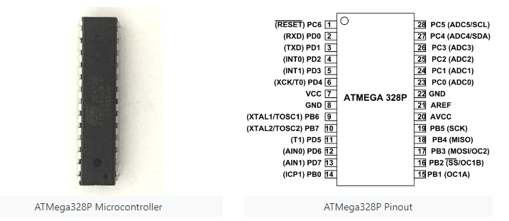

Figure 1.ATMega328P Microcontroller

## **2.2.2 ULTRASONIC SENSOR**

An ultrasonic sensor is an electronic device that emits ultrasonic sound waves and converts the reflected sound into an electrical signal to determine the distance between a target object and itself. Ultrasonic waves travel at a faster rate than audible sound waves (i.e. the sound that humans can hear). The transmitter (which emits sound via piezoelectric crystals) and the receiver are the two main components of ultrasonic sensors (which encounters the sound after it has travelled to and from the target).

### **2.2.2.1 How Ultrasonic Sensors Work.**

Ultrasonic sensors operate by emitting a sound wave at a frequency that is above the range of human hearing. To receive and transmit ultrasonic sound, the sensor's transducer functions as a microphone. A single transducer is used by ultrasonic sensors to send a pulse and receive the echo. The sensor calculates the distance to a target by measuring the time between sending and receiving an ultrasonic pulse.

This module's operation is straightforward. It emits a 40kHz ultrasonic pulse that travels through the air and, if it encounters an obstacle or object, bounces back to the sensor. The distance can be calculated by multiplying the travel time by the speed of sound. To calculate the distance between the sensor and the object, the sensor measures the time it takes from the transmitter's sound emission to its contact with the receiver. D = 1/2 T x C (where D is the distance, T is the time, and C is the sound speed of 343 meters/second) is the formula for this calculation.

### **2.2.2.2 How are Ultrasonic Sensors used**

Ultrasonic distance, level, and proximity sensors are frequently used in conjunction with microcontroller platforms such as Raspberry Pi, ARM, PIC, Arduino, Beagle Board, and others.

Ultrasonic sensors send sound waves toward a target and measure the time it takes for the reflected waves to return to the receiver to determine its distance.

This sensor is an electronic device that uses ultrasonic sound waves to measure the distance to a target and then converts the reflected sound into an electrical signal.

As a proximity sensor, ultrasonic sensors are frequently used.

Ultrasonic sensors are also used in obstacle detection systems and manufacturing.

ShortRange sensors allow for closer range detection in situations where a sensor that ranges objects as close as 2cm is required. These are also designed with very low power requirements in mind, as well as environments requiring noise rejection.

### **2.2.2.3 When Not to Use an Ultrasonic Sensor**

The need for an ultrasonic sensor is defeated when the target object is so small that the reflected ultrasonic signal is insufficient for detection and the distance cannot be accurately measured.

### **2.2.2.4 Using Your Ultrasonic Sensor in Your Project**

1. **HOOK UP CONTROLLER**

**2. INSTALL SOFTWARE**

Install Kiel coding software onto your PC. This is where you type the code you want to compile and send to the microcontroller board.

**3. SET UP YOUR SENSOR WITH THE PROGRAMMER**

Plug your programmer into the USB cable and into your computer. Once you upload the programmer, you can then compile and activate the code.

**4. COMPILE AND RUN CODE**

### **2.2.2.5 Why use an Ultrasonic Sensor**

Because ultrasonics are so widely used, they can be reliably implemented in grain bin sensing applications, water level sensing applications, drone applications, ultrasonic sensors can handle collision avoidance for a robot, and sensing cars at your local drive-thru restaurant or bank.

Ultrasonic rangefinders are frequently used as collision detection devices.

Ultrasonic Sensors are best used for non-contact detection of:

* Presence
* Level
* Position
* Distance

Non-contact sensors are also referred to as proximity sensors.

Ultrasonics are Independent of:

* Light
* Smoke
* Dust
* Color

(With the exception of soft surfaces, such as wool, which absorbs the ultrasonic sound wave rather than reflecting it.)

Ultrasonic sensors are a reliable choice for detecting transparent and other items where optical technologies may fail.

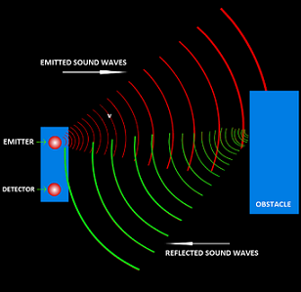

Figure 2.Ultrasonic working diagram

The level of garbage in the waste bin will be detected using an ultrasonic sensor. The level of garbage will be represented by the distance between the sensor and the garbage in the dustbin. VCC (5V), Trig, Echo, and GND are the four pins on this module. Trig must be used to send out an ultrasonic high level pulse for at least 10s before the Echo Pin detects the returning pulse. To determine the distance, this sensor will calculate the time interval between sending the signal and receiving the echo. The ultrasonic sensor has a working frequency of 40Hz. The maximum and minimum ranges are 4m and 2cm, respectively, and the measuring angle is 15 degrees.

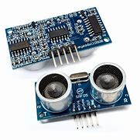

Figure 3. Ultrasonic Sensor

## **2.2.3 GSM/GPRS MODULE**

GSM, or Global System for Mobile Communications, is the most widely used wireless cellular communication technique for public use. The GSM standard was created to define protocols for digital cellular networks of the second generation (2G).

It began as a circuit switching network, but after incorporating General Packet Radio Service (GPRS) technology, packet switching was implemented. GSM frequency bands that are commonly used are 900 MHz and 1800 MHz.

GSM operates in the 900 to 1800 MHz frequency range in Europe and Asia, while it operates in the 850 to 1900 MHz frequency range in the United States and other American countries. It employs the digital air interface, which converts analog signals to digital signals before transmission. The transfer rate is 270 Kbps.

The Global System for Mobile Communications (GSM) is currently used by approximately 80% of mobile phones worldwide. This technology is used by over three billion people.

GPRS, or General Packet Radio Service, is a GSM Network extension. GPRS is an integrated part of the GSM Network that provides an efficient way of transferring data while using the same resources as the GSM Network.

Originally, the GSM Network's data services (such as internet, multimedia messaging, and so on) relied on a circuit-switched connection. The network access time is long in this type, and data charges are based on connection time. Furthermore, this connection is unsuitable for sending data bursts.

The integration of GPRS, a packet-switching-based data service, into the GSM Network has altered the data service landscape. In GPRS-based packet-switching networks, the user device does not retain resources indefinitely, but instead makes efficient use of a shared pool.

GPRS has a very short access time and the main advantage is that it allows data bursts to be transmitted. Furthermore, data charges are assessed based on usage rather than connection time.

### **2.2.3.1 GSM History**

The GSM standard was created in 1982 by a committee of the Conference Europeenne des Postes et Telecommunications (CEPT) (Recent – European Telecommunications Standard Institute), the European Standard Organization, as a new mobile communications standard in the 900 MHz frequency band.

The primary goal was to establish an international standard for wireless mobile communications. In 1991, Finland launched the first GSM-based mobile services, and the acronym was changed to Global System for Mobile Communications. Simultaneously, the first digital cellular system, known as GSM-1800, was developed based on GSM recommendations.

### **2.2.3.2GSM Architecture**

GSM architecture is divided into three sections: the Radio Subsystem, the Network and Switching Subsystem, and the Operation Subsystem. The radio subsystem is made up of the Mobile Station Subsystem and the Base Station Subsystem.

The mobile station is typically a mobile phone that includes a transceiver, display, and processor. Each handheld or portable mobile station contains a unique identity stored in a SIM module (Subscriber Identity Chip). It is a small microchip that is inserted into the mobile phone and contains the mobile station's database.

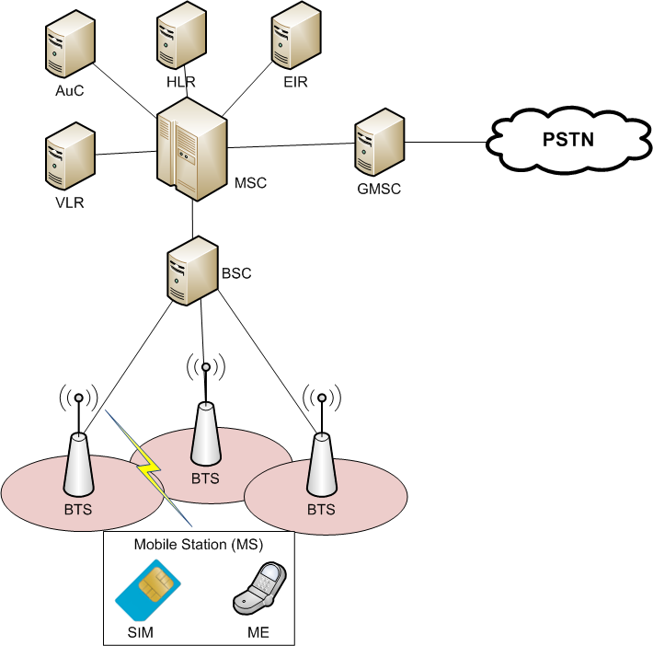

Figure 4. The base station subsystem

**The base station subsystem**

It connects the mobile station with the network subsystem via the air interface.

**It consists of the below given elements:**

**Base Transceiver Station**: One or more Base Transceiver Stations provide a physical connection to the network in the form of an air interface for a mobile station. It can have various configurations depending on the load, subscriber behavior, and morph structure – Standard configuration (each BTS is given a unique cell identity (CI), and a group of BTSs forms a location area).

The Umbrella Cell layout (One BTS with high transmission power installed at a higher altitude, acting as an umbrella to the lower transmission power Base Transmitter Stations), Collocated configurations (multiple BTSs collocated at one site, but antennas only cover a small area) 120 Alternatively, 180 degrees). It is a network of neighboring radio cells that covers the entire service area.

**Base Station Controller**: It manages the operation of one or more Base Transceiver Stations, essentially the handover or power control. A BSC communicates with a BTS via an Abis-interface. It consists of a database containing the entire maintenance status of the BTS, the quality of radio and terrestrial resources, and BTS operations software).

**Transcoding Rate and Adaption Unit:** It sits between a Base Station Controller and a Mobile Switching Centre. It compresses and decompresses mobile station speech. It is not, however, used for data transmission.

**Network Switching Subsystem:** It includes all of the control and database functions required to set up a call with encryption, authentication, and roaming capabilities. Its primary function is to connect the Mobile Station to the network. It is made up of the components listed below.

**Mobile Switching Centre:** It is the most important component of the GSM network as a whole. It is analogous to a PSTN or ISDN exchange. It supports additional functionality such as registration, authentication, call location, and call routing to the subscriber in addition to the standard functionality.

It offers interfaces to the Public Switched Telephone Network (PSTN) for landline connections and interfaces to another Mobile Switching Centre (MSC) for mobile phone connections.

**Home Location Register:** It is a repository for data belonging to a large number of subscribers. It is essentially a large database that manages data for each subscriber. It keeps subscriber-specific parameters like Ki, which are known only to the HLR and the SIM, for security reasons.

**Virtual Location Register:** It is similar to the Home Location Register (HLR), but it differs in that it stores dynamic information about subscriber data. It comes into play when a subscriber moves from one location to another while roaming. The data is saved in the Equipment Identity Register, which keeps track of all mobile stations, each of which is identified by its International Mobile Equipment Identity (IMEI) number.

### **2.2.3.3 How GSM communication works**

The Global System for Mobile Communications (GSM) employs both Time Division Multiple Access (TDMA) and Frequency Division Multiple Access (FDMA) (FDMA).

Frequency Division Multiple Access (FDMA) is the process of dividing a frequency band into multiple bands, each of which is assigned to a single subscriber. In GSM, FDMA divides the 25MHz bandwidth into 124 carrier frequencies separated by 200 KHz. One or more carrier frequencies are assigned to each base station.

**Time Division Multiple Access**: It entails dividing the frequency band into multiple time slots and allocating the same frequency channel to different subscribers. Each user is assigned a timeslot, allowing multiple stations to share the same transmission space.

TDMA is used in GSM to divide each subdivided carrier frequency into different time slots. Each TDMA frame has eight time slots and lasts 4.164 milliseconds (ms). Each time slot or physical channel within this frame lasts 577 microseconds, and data is transmitted in bursts during that time slot.

### **2.2.3.4 GSM/GPRS Module**

A GSM/GPRS Module is an integrated circuit (IC) or chip that communicates with the GSM Network via a SIM (Subscriber Identity Module) and Radio Waves. A typical GSM Module operates on the radio frequencies 850MHz, 900MHz, 1800MHz, and 1900MHz.

Because it is not possible to connect a GSM/GPRS Module directly to an external device such as a microcontroller, we need a setup similar to the one shown in the image below.

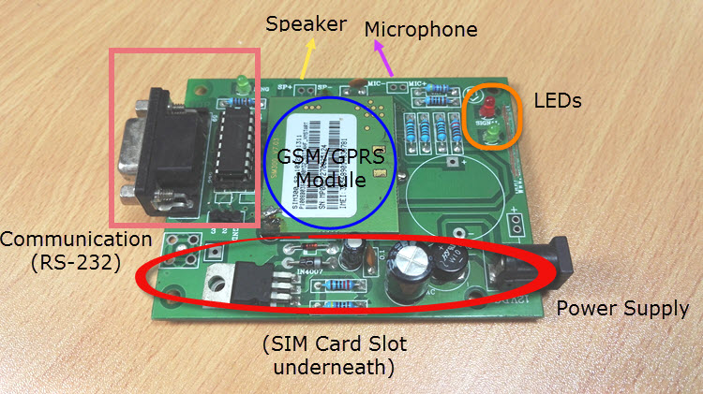

Figure 5. GSM module

It is made up of the GSM/GPRS Module, a SIM Card slot, an RS-232 interface for connecting to a computer or a microcontroller, a signal status LED, a power supply, and a provision for connecting a microphone and speaker.

Each GSM/GPRS Module is distinct and can be identified by its IMEI Number. The International Mobile Equipment Identity Number, or IMEI, is a 15-digit unique number associated with mobile phones, satellite phones, and other GSM Network devices.

### **2.2.3.5 Features of GSM Module**

The features of the GSM module include the following.

* Improved spectrum efficiency
* International roaming
* Compatibility with integrated services digital network (ISDN)
* Support for new services.
* SIM phonebook management
* Fixed dialing number (FDN)
* Real-time clock with alarm management
* High-quality speech
* Uses encryption to make phone calls more secure
* Short message service (SMS)

The GSM system is the most secure telecommunications standard currently available due to the security strategies that have been standardized for it. Although the confidentiality of a call and the secrecy of the GSM subscriber is only guaranteed on the radio channel, this is a significant step toward achieving end-to-end security.

## **2.2.4 SERVO MOTOR**

A servo motor is a type of electromechanical device that generates torque and velocity based on the current and voltage supplied. A servo motor is part of a closed loop system that provides torque and velocity as commanded by a servo controller, with the loop closed by a feedback device. The feedback device sends information to the servo controller, which adjusts the motor action based on the commanded parameters, such as current, velocity, or position. The term servo was coined by Joseph Facort in 1859, when he implemented a feedback mechanism to assist in steering a ship using steam to control the rudders. A servo motor is a component of a servo mechanism, which consists of three major components: a motor, a feedback device, and control electronics. The motor can be alternating current or direct current, brushed or brushless, rotary or linear, and of any size. A potentiometer, Hall-effect device, tachometer, resolver, encoder, linear transducer, or any other sensor as appropriate can be used as the feedback device. The control electronics that powers the motor and compares feedback data and command reference to ensure that the servo motor is operating properly round out the servo system. The Servo Motor aids in automatically opening the dustbin lid.

### **2.2.4.1 Servo Motor Working Mechanism**

It consists of three parts:

* Controlled device
* Output sensor
* Feedback system

It is a closed-loop system that controls motion and the final position of the shaft using a positive feedback system. A feedback signal generated by comparing the output signal and the reference input signal is used to control the device in this case.

The reference input signal is compared to the reference output signal, and the feedback system produces the third signal. And the third signal serves as an input signal to the device's control. This signal exists as long as the feedback signal is present or there is a difference between the reference input and reference output signals. As a result, the main task of servomechanism is to keep a system's output at the desired value in the presence of noise.

The PWM (Pulse Width Modulation) principle is used by servo motors, which means that the angle of rotation is controlled by the duration of the pulse applied to its control PIN. A servo motor is essentially a DC motor that is controlled by a variable resistor (potentiometer) and some gears.

### **2.2.4.2 Interfacing Servo Motors with Microcontrollers**

There are three wires that come out of servos. Two of which will be used for supply (positive and negative) and one for the signal to be sent from the MCU. Your servo motor's color coding may differ; therefore, consult your datasheet.

All servo motors operate directly from your +5V supply rails, but we must be mindful of the amount of current the motor consumes. If you intend to use more than two servo motors, a proper servo shield must be designed.

### **2.2.4.3 Advantages:**

* If the motor is subjected to a heavy load, the driver will increase the current to the motor coil in order to rotate the motor. There is no condition that is out of sync.
* It is possible to operate at high speeds.

### **2.2.4.4 Disadvantages:**

* Because the servomotor tries to rotate in response to the command pulses but lags, it is not suitable for precision rotation control.
* Higher cost.
* When stopped, the motor’s rotor continues to move back and forth one pulse, so that it is not suitable if you need to prevent vibration

### **2.2.4.5 Applications of Servo Motors**

Servomotors are used in applications requiring rapid variations in speed without the motor getting overheated.

* In the manufacturing industry, they are used in machine tools, packaging, factory automation, material handling, printing converting, assembly lines, and a variety of other demanding applications robotics, CNC machinery, or automated manufacturing.
* They're also used to control the positioning and movement of elevators in radio-controlled planes.
* They are used in robots because of their smooth on/off switching and precise positioning.
* They are also used in the aerospace industry to keep hydraulic fluid in their hydraulic systems lubricated.
* They are found in a variety of radio-controlled toys.
* They are used in electronic devices such as DVD or Blu-ray Disc players to extend or replay the disc trays.
* They are also used in automobiles to keep vehicles moving at a constant speed.

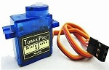

Figure 6. Servo Motor

## **2.2.5 MQ135 SENSOR**

Ammonia, nitrogen, oxygen, alcohols, aromatic compounds, sulfide, and smoke are all detected by the MQ-135 gas sensor. The chip MQ-3 gas sensor's boost converter is PT1301. This gas sensor's operating voltage ranges from 2.5V to 5.0V. As a gas sensing material, the MQ-3 gas sensor has a lower conductivity to clean the air. Polluting gases can be detected in the atmosphere, but the conductivity of the gas sensor increases as the concentration of polluting gas increases. The MQ-135 gas sensor can detect smoke, benzene, steam, and other harmful gases. It has the capability of detecting various harmful gases.

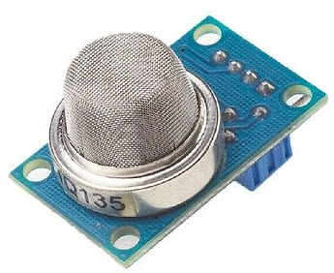

Figure 7. MQ-135 Gas Sensor

### **2.2.5.1 Basic Pin Configuration of Alcohol Sensor**

The MQ-3 alcohol gas sensor has a total of six pins, including A, H, and B, and we only use four of them. The two pins A and H are for heating, while the other two pins are for grounding and power. A heating system made of aluminum oxide and tin dioxide is located inside the sensor. It is used as a heat sensor because it has heat coils that produce heat. The pin diagram and configuration of the MQ-3 alcohol sensor are depicted in the diagram below.

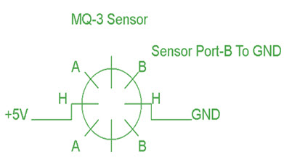

Figure 8. Pin Configuration of Alcohol Sensor

### **2.2.5.2 Working Principle and Circuit Diagram**

The MQ-135 alcohol sensor is made up of a tin dioxide (SnO2) layer, a perspective layer inside aluminum oxide microtubes (measuring electrodes), and a heating element housed inside a tubular casing. A stainless steel net surrounds the sensor's end face, and the connection terminals are located on the backside. Passing through the heating element, ethyl alcohol in the breath is oxidized to acetic acid. Resistance decreases with the ethyl alcohol cascade on the tin dioxide sensing layer. The resistance variation is converted into a suitable voltage variation by using the external load resistance. The circuit diagram and connection configuration for MQ 135 sensor is shown below.

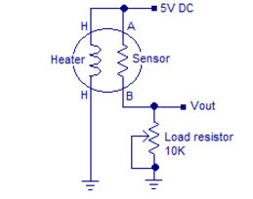

Figure 9. MQ135 Circuit Diagram

### **2.2.5.3 MQ – 135 Air Quality Sensor**

The air quality sensor also functions as a MQ-135 sensor, which detects venomous gases in the air in homes and offices. Tin dioxide (SnO2) is used in the sensor unit's gas sensor layer; it has a lower conductivity than clean hair and increases in conductivity due to air pollution. Ammonia, nitrogen oxide, smoke, CO2, and other hazardous gases are detected by the air quality sensor. A small potentiometer on the air quality sensor allows you to adjust the load resistance of the sensor circuit. The air quality sensor runs on a 5V power supply.

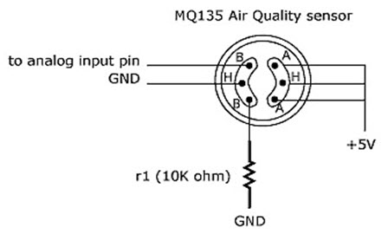

Figure 10. MQ – 135 Air Quality Sensor

A signal output indicator instruction is the air quality sensor. There are two outputs: analog and TTL. TTL output is a low signal light that can be accessed via the Microcontroller's IO ports. Because the analog output is a concentration, increasing voltage is proportional to increasing concentration. This sensor has a long life span and a high level of dependability.

### **2.2.5.4 Applications of MQ 135 Gas Sensor**

The following are the applications of the MQ 135 gas sensor:

* Air quality monitor
* Detection of harmful gases
* Domestic air pollution detection
* Industrial pollution detection
* Portable air pollution detection
* Breathalyzer for alcohol level test

### **2.2.5.5 Characteristics of MQ 135**

* Good sensitivity to harmful gases in a wide range.
* It has a long life and low cost.
* Possesses high sensitivity to ammonia, benzene, sulfide gases.
* It is a simple drive circuit
* It is of low cost to purchase.

## **2.2.6 WEB DEVELOPMENT**

The work involved in creating a Web site for the Internet (World Wide Web) or an intranet is known as web development (a private network). Web development can include anything from creating a single static page of plain text to creating complex web applications, electronic businesses, and social network services. Web engineering, Web design, Web content development, client liaison, client-side/server-side scripting, Web server and network security configuration, and e-commerce development are some of the more comprehensive tasks to which Web development commonly refers.

"Web development" is commonly used among Web professionals to refer to the main non-design aspects of building Web sites: writing markup and coding. Content management systems (CMS) may be used in web development to make content changes easier and more accessible to those with basic technical skills.

### **2.2.6.1 Cloud/Web Based Application**

Web-based applications are software environments with an integrated set of tools and functionalities that can be accessed using a web browser. (J. Collis, 2005) The world wide web is the foundation for web-based applications.

(Meshram & Ingle, 2012) Web-based systems are defined as those that make use of the internet, intranets, and extranets. The phrases "internet" and "world wide web" are frequently interchanged. The two, however, are not the same. The internet is a global network of interconnected computer networks that exchange data using the standardized internet protocol suite (TCP/IP) and packet switching. The World Wide Web, on the other hand, is a global collection of documents and other resources linked together by hyperlinks and urls. HTTP, one of many internet communication protocols, is commonly used to access web resources. Web-based systems are based on web technologies and can be used in both private and public networks (public network).

**2.2.6.2 Importance Of Web Based System**  
**1. Cost Efficiency:** A web-based office system can automate your business procedures, allowing you to focus on your core competencies. It can also help you eliminate inefficiencies in your present business operations, allowing you to reallocate resources to more proactive and productive tasks. Naturally, this can lead to cost savings in the form of lower employee costs, reduced inefficiencies, improved sales, and higher profits.  
**2. Cross Platform Compatibility:** A web-based application has the advantage of requiring only an up-to-date browser, such as Internet Explorer, Google Chrome, or Mozilla Firefox, and is not limited by the limitations of the business's operating system. A web-based system will work regardless of whether the company runs Windows, Mac OS, or Linux, as long as the end user has access to an internet browser and an internet connection.  
**3. More Manageable:** Web-based solutions only require server installation, with minimal requirements on the end user's workstation. This makes system maintenance and updates considerably easier because everything can usually be done on the server. Any client updates can be easily distributed via the web server.  
**4. Highly Deployable:** Deploying web apps to end users is significantly easier due to manageability and multi-platform support. They're also great for situations where bandwidth is limited and the system and data are located far away from the user. You only need to send the user a website address to log in to and supply them with internet access to make them deployable. This has major consequences since it allows you to provide more customers, suppliers, and third parties access to your systems, allowing you to streamline operations and strengthen connections.

**2.2.6.3 Design Methodologies for Web Based Systems**

Development methodologies for web-based systems have been ad hoc, according to (Murugesan San, et al., 2016). Development approaches, measurement and evaluation techniques, application quality, and project management were all given little consideration. Furthermore, the majority of current application development and management processes rely primarily on individual developers' knowledge and experience as well as their own development practices. They also lack sufficient testing of web-based systems as well as documentation, which is required for system maintenance and upgrades, among other things. More complicated and dynamic applications have emerged as the web advances from a hypertext to a hypermedia platform, demonstrating the necessity for a well-defined strategy in the development of web-based applications. 2012 (Ingle & Meshram) Four (4) general strategies for developing web-based systems were noted. These are some of the methods:

**1. Data Oriented Methods:** These are based on the ER (Entity-Relationship) paradigm and are from the field of database systems. The modeling of database-driven web applications is the core emphasis of these methodologies.

**2. Hypertext-Oriented Methods (HOM**): HOM is concerned with the hypertext nature of web applications. Hypertext Design Model (HDM)-1993, later HDM expanded to W2000 and HDM-lite-1996, and WSDM-1997 are some of these methodologies.

**3. Object Oriented Methods:** These methods are either based on OMT or UML. Object Oriented Hypermedia Design Method (OOHDM) – 1996, UML based web engineering – 2000, object oriented web solutions (OOWS) – 2001, and object Oriented Hypermedia (OO-H) – 2002 are all included in this category. WebSA-2004. 4. Software-Oriented Approaches: It employs procedures that closely resemble those used in traditional software development. Web Application Extension (WAE) 1999 and the improved version WAE2-2001 are examples of thiscategory.  
**2.2.6.4 Architecture of Web Based System**

The relationships between web applications, databases, and middleware systems are described by web application architecture. It ensures that numerous apps can run at the same time. Let's have a look at how to open a webpage as an example. When a user types a URL into a web browser's address bar and then presses the go button, the browser requests that URL. As a response to your request, the server transmits files to your browser. The browser then displays the requested page by executing those files. Finally, the website allows the user to engage with it. The code interpreted by the web browser is the most crucial thing to pay attention to. A web app functions in the same way. This code may or may not contain specific instructions telling the browser how to respond to various types of user inputs. As a result, a web application architecture must include all of the sub-components as well as the external application interchanges for the entire software application, which in the aforementioned case is a website. Web application architecture is essential in today's world because web-based communication is used by the majority of apps and devices, as well as a large portion of global network traffic. A web application architecture must address not only efficiency, but also reliability, scalability, security, and robustness. In any typical web application, two different codes (sub-programs) are running concurrently. These are:

1. **Client-side Code** - The code that runs in the browser and reacts to user input
2. **Server-side Code** - The server-side code that responds to HTTP requests. A web developer (team) creating the web application decides what the server code will do in relation to the browser code. C#, Java, JavaScript, Python, PHP, Ruby, and other programming languages are used for server-side code. A server can run any code that can respond to HTTP requests. The server side code is in charge of generating the requested page as well as storing various types of data such as user profiles and user input. The end-user is never aware of it.

**2.2.6.5 Web Application Components**

Web application components include the following:

* **UI/UX Web Application Components** – This includes things like activity logs, dashboards, notifications, settings, statistics, and so on. These components have nothing to do with how a web application architecture works. Instead, they are part of a web app's interface layout plan.

1. **Structural Components** – Client and server sides are the two major structural components of a web app.
2. **Client Component** - CSS, HTML, and JS are used to build the client component. There is no need for operating system or device-related changes because it exists within the user's web browser. The client component is a graphical representation of the functionality of a web application with which the end user interacts.
3. **Server Component** - The server component can be written in one or more programming languages and frameworks, such as Java,.Net, NodeJS, PHP, Python, and Ruby on Rails. The server component consists of at least two components: application logic and a database. The former serves as the web application's main control center, while the latter houses all persistent data.

### **2.2.4.6 Models Of Web Application Components**

The model of a web application is determined by the total number of servers and databases that are used for it. It could be one of the three possibilities listed below:

1. **One Web Server, One Database:** It is the most basic, but also the least reliable, web app component model. A single server and database are used in this model. A web app built on such a model will fail as soon as the server fails. As a result, it is untrustworthy. For real web applications, the one web server, one database web application component model is not commonly used. It is primarily used to run test projects as well as to learn and understand the fundamentals of the web application.
2. **Multiple Web Servers, One Database (At a Machine Rather than the Web server):** The webserver does not store any data in this type of web application component model. When the webserver receives data from a client, it processes it and writes it to a database that is managed outside of the server. This is also referred to as a stateless architecture. This web application component model necessitates the use of at least two web servers. All of this is done to avoid failure. Even if one of the web servers fails, the other one will take over. All subsequent requests will be automatically redirected to the new server, and the web app will continue to run. As a result, reliability is higher than with a single server with an inherent database model. However, if the database crashes, the web app will do the same.
3. **Multiple Web Server, Multiple Databases:** It is the most efficient web application component model because neither the webservers nor the databases have a single point of failure. This model has two options. Either store identical data in all databases used or distribute it evenly among them. In the former case, no more than two databases are usually required, whereas in the latter case, some data may become unavailable in the event of a database crash. DBMS normalization, on the other hand, is used in both scenarios.

### **2.2.4.7 Theory of Web Technology Used**

HTML, CSS, and JavaScript were used in the development of the Smart Bin web application. JavaScript, also known as JS, is a programming language that adheres to the ECMAScript specification. JavaScript is a high-level programming language that is often compiled just-in-time and is multi-paradigm. Curly-bracket syntax, dynamic typing, prototype-based object-orientation, and first-class functions are all included.

JavaScript, along with HTML and CSS, is one of the core technologies of the World Wide Web. Over 97 percent of websites use it client-side for web page behavior, frequently incorporating third-party libraries. All major web browsers include a JavaScript engine that executes code on the user's device.

JavaScript supports event-driven, functional, and imperative programming styles as a multi-paradigm language. It supports text, dates, regular expressions, standard data structures, and the Document Object Model through application programming interfaces (APIs) (DOM).

#### **2.2.4.7.1 JavaScript**

JavaScript is a dynamic programming language used in computers. It is lightweight and most commonly used as a component of web pages, where its implementations allow client-side script to interact with the user and create dynamic pages. It is an object-oriented, interpreted programming language. A website today must go far beyond HTML. There is a clear requirement for users who are browsing a website to be able to interact with it. The web must be intelligent enough to accept user input and dynamically structure web page content that is tailored to the needs of a user. Users today prefer to view only what interests them when they visit a website. As a result, even the content of a web page must be dynamic based on what a user wants to see. This necessitates the creation of interactive web pages, which necessitates the development of a website. Forms are traditionally used to collect user requests. Validation should be available in the web site development environment. JavaScript is an object-oriented programming language that enables the creation of interactive web pages.

#### **2.2.4.7.2 HTML5 and CSS3**

HTM (Hypertext Markup Language) and CSS (Cascading Style Sheets) are two of the primary technologies used to create Web pages. CSS provides the (visual and aural) layout for a variety of devices, while HTML provides the page structure. HTML and CSS, along with graphics and scripting, form the foundation of Web pages and Web Applications. The language used to describe the structure of Web pages is HTML. Authors can use HTML to express themselves in a variety of ways:

* Create online documents with headings, text, tables, lists, photos, and so on.
* At the push of a button, you can access online information via hypertext links.
* Create forms for interacting with remote services, such as searching for information, making reservations, ordering products, and so on.
* Spreadsheets, video clips, sound clips, and other applications can be included directly in their documents.

Authors use markup to describe the structure of pages in HTML. Language elements label pieces of content such as "paragraph," "list," "table," and so on.

CSS is a language used to describe the appearance of Web pages, such as colors, layout, and fonts. It enables the presentation to be tailored to different types of devices, such as large screens, small screens, or printers. CSS is not dependent on HTML and can be used with any XML-based markup language. The separation of HTML and CSS makes it easier to maintain sites, share style sheets across pages, and tailor pages to different environments. This is known as the separation of structure or content from presentation..

### **2.2.4.8 Web Technologies Used**

* **React** (also known as React.js or ReactJS) is a free and open-source front-end JavaScript library for building user interfaces or UI components. It is run by Facebook and a community of individual developers and businesses. React can be used as a foundation for single-page or mobile applications. However, because React is only concerned with state management and rendering that state to the DOM, creating React applications usually necessitates the use of additional libraries for routing and client-side functionality. (Wikipedia 2021)
* **Node.js** is an open-source, cross-platform, back-end JavaScript runtime environment that runs on the V8 engine and executes JavaScript code outside a web browser. Node.js allows developers to use JavaScript to create command line tools and server-side scripting, which involves running scripts on the server to generate dynamic web page content before the page is sent to the user's web browser. As a result, Node.js represents a "JavaScript everywhere" paradigm, bringing web-application development together around a single programming language rather than separate languages for server-side and client-side scripts.
* **Socket.IO** is a real-time web application JavaScript library. It enables bidirectional, real-time communication between web clients and servers. It is divided into two parts: a client-side library that runs in the browser and a server-side Node.js library. The APIs of both components are nearly identical. It is event-driven, just like Node.js. While providing the same interface, Socket.IO primarily uses the WebSocket protocol, with polling as a fallback option. Although it can be used as a simple WebSocket wrapper, it has many more features, such as broadcasting to multiple sockets, storing data associated with each client, and asynchronous I/O.
* **MongoDB** is an open-source, cross-platform document-oriented database program. MongoDB is a NoSQL database program that uses JSON-like documents with optional schemas. MongoDB was created by MongoDB Inc. and is licensed under the Server-Side Public License (SSPL).

### **2.2.4.9 Development Environment**

* **Ubuntu Linux**

Ubuntu is a Linux distribution based on Debian and composed mostly of free and open-source software. Ubuntu is officially released in three editions: Desktop, Server, and Core for Internet of things devices and robots. All the editions can run on the computer alone, or in a virtual machine. Ubuntu is a popular operating system for cloud computing, with support for OpenStack. Ubuntu's default desktop has been GNOME, since version 17.10. Ubuntu is developed by Canonical, and a community of other developers, under a meritocratic governance model (Wikipedia, 2021).

* **Visual Studio Code**

Visual Studio Code is a source-code editor developed by Microsoft for Windows, Linux and macOS. It includes support for debugging, embedded Git control and GitHub, syntax highlighting, intelligent code completion, snippets, and code refactoring. It is highly customizable, allowing users to change the theme, keyboard shortcuts, preferences, and install extensions that add additional functionality. The source code is free and open source and released under the permissive MIT License. The compiled binaries are freeware and free for private or commercial use (Wikipedia, 2021).

* Postman

Postman is the world’s leading collaboration platform for API development. Postman's features simplify each step of building an API and streamline collaboration to help create better APIs—faster. More than 15 million developers and 500,000 organizations worldwide use Postman today.

Data is transferred using the GSM module to the web based application by using the GPRS capability of the module. The data movement diagram that describes the movement of data across the complete system, that is, from the electronic device to the web platform and back is show in the diagram below.

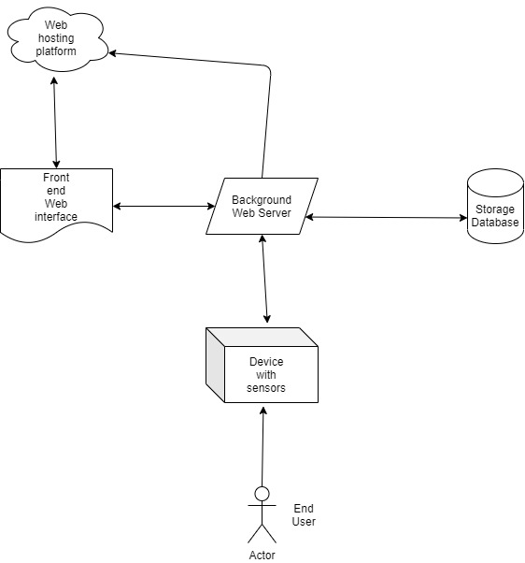

Figure 11. Block diagram of data movement in the System

From the diagram above, it is proposed that the sensor readings from the end user device will be sent to the backend web server using HTTP POST request (this will be done continuously, every 10 seconds). These sensor readings will contain the depth and smell of the device as read from the GPS sensor onboard the device.

## **2.2.5 DC to DC Converter**

A DC-DC is an electronic power transformer that accepts a DC input voltage as well as a DC output voltage. The DC-to-DC converter output voltage may be greater than or vice versa. The output voltages of the converter correspond to the power supply required for the load. The power supply can be connected and disconnected to the load with a switch on a simple DC to DC converter. The DC to DC converters consists of a transistor or diode switch, energy storage devices such as inducers or condensers and are generally used as linear voltage controllers or as switched voltage controllers. DC to DC transformers are employed to supply electrical and electronics electric circuits with DC regulated power supplies and constant DC power supplies.

### **2.2.5.1 DC to DC Converter Operating Principle and Functionality**

In order to understand the principle of operation and functionality of DC to DC converters, consider the working principle of DC to DC buck boost converters.

### **2.2.5.2 DC to DC Buck Boost Converter**

The buck boost converter is a direct current to direct current converter. The output voltage of the DC to DC converter is either less than or greater than the input voltage. The magnitude of the output voltage is determined by the duty cycle. These converters are also known as step up and step down transformers, after the analogous step up and step down transformer. The input voltages are stepped up/down to a level that is greater or less than the input voltage. The input power is equal to the output power when the conversion energy is low. The low of a conversion is represented by the expression below.

Power input (Pin) = Power output (Pout)

The input voltage is less than the output voltage (Vin< Vout) when using the step up mode. The output current is less than the input current, indicating that the output current is less than the input current. As a result, the buck booster operates in a step-up mode.

Vin and Vout > Iout

The input voltage is greater than the output voltage (Vin > Vout) when in step down mode. The output current is therefore greater than the input current. As a result, the buck boost converter operates in the step down mode.

Vin vs. Vout and Iout vs. Iout

### **2.2.5.3 What is a Buck Boost Converter?**

It is a type of [DC to DC converter](https://www.elprocus.com/buck-boost-converter-circuit-theory-working-applications/)and it has a magnitude of output voltage. It may be more or less than equal to the input voltage magnitude. The buck boost converter is equal to [the fly back circuit](https://www.elprocus.com/freewheeling-or-flyback-diode-circuit-working-functions/)and single inductor is used in the place of the transformer. There are two types of converters in the buck boost converter that are buck converter and the other one is boost converter. These converters can produce the range of output voltage than the input voltage. The following diagram shows the basic buck boost converter.

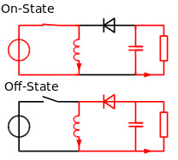

Figure 12. Buck Boost Converter

### **2.2.5.4 Working principle of Buck-Boost Converter**

The inductor in the input resistance has an unexpected variation in the input current during the operation of the DC to DC converter. When the switch is turned on, the inductor receives energy from the input and stores it as magnetic energy. When the switch is closed, the energy is discharged. The capacitor's output circuit is assumed to be high enough that the time constant of an RC circuit is high on the output stage. The long time constant is compared to the switching period to ensure that the steady state has a constant output voltage Vo(t) = Vo(constant) and is present at the load terminal.

There are two different types of working principles in the buck boost converter.

* Buck converter.
* Boost converter.

Buck Converter Working

The buck converter's operation is depicted in the diagram below. Due to the high square wave frequency, the first transistor in the buck converter is turned on and the second transistor is switched off. If the current passing through the magnetic field is greater than the current passing through the gate terminal of the first transistor, charging C occurs, and the load is supplied. The Schottky diode, D1, is turned off by the positive voltage applied to the cathode.

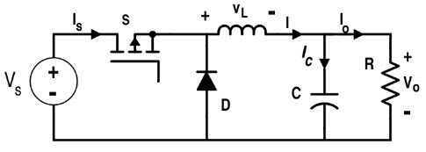

Figure 13. Buck Converter Working

The initial source of current is the inductor L. If the first transistor is turned off using the control unit, current flows in the buck operation. The inductor's magnetic field is collapsed, and the back e.m.f. is generated as the collapsing field rotates around the polarity of the voltage across the inductor. The current will flow in the diode D2, the load, and the D1 diode.

With the help of the current, the discharge of the inductor L decreases. The charge of the accumulator in the capacitor is in one state during the first transistor. During the off period, the current flows through the load while keeping Vout reasonably stable. As a result, it keeps the ripple amplitude to a minimum and Vout close to the value of Vs.

**Boost Converter Working**

The first transistor in this converter is turned on continuously, while the gate terminal of the second transistor receives a high-frequency square wave. When the second transistor is in the conducting state, the inductor L's input current flows through it. The inductor's magnetic field is being charged by the negative terminal. Because the anode of the D2 diode is on potential ground due to the highly conducting second transistor, the D2 diode cannot conduct.

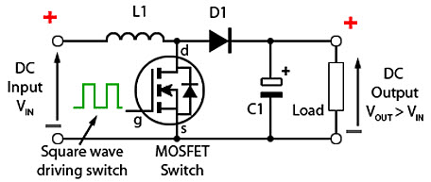

Figure 14. Boost Converter Working

The load is applied to the entire circuit in the ON State by charging the capacitor C, and it can construct earlier oscillator cycles. During the ON period, capacitor C can discharge on a regular basis, resulting in a high ripple frequency on the output voltage. The equation below gives an approximation of the potential difference.

**VS + VL**

The inductor L charges and the capacitor C discharges during the OFF period of the second transistor. The inductor L can generate the back e.m.f., and the values depend on the rate of change of the current of the second transistor switch. The maximum inductance that a coil can have. As a result, the back e.m.f. can generate any voltage over a wide range, as determined by the circuit design. As a result, the voltage across the inductor L has now reversed polarity.

The output voltage is equal to or greater than the input voltage. The diode D2 is forward biased, and the current applied to the load current recharges the capacitors to VS + VL, allowing the second transistor to operate.

### **2.2.5.5 Modes of Buck Boost Converters**

In the buck boost converter, there are two types of modes. The two types of buck boost converters are as follows.

* Continuous conduction mode.
* Discontinuous conduction mode.

#### **2.2.5.5.1 Continuous Conduction Mode**

In the continuous conduction mode, the current from end to end of the inductor is never zero. As a result, the inductor partially discharges prior to the switching cycle.

#### **2.2.5.5.2 Discontinuous Conduction Mode**

The current through the inductor is zero in this mode. As a result, at the end of the switching cycles, the inductor will be completely discharged.

### **2.2.5.6 Applications of Buck boost converter**

* It is used in the self-regulating power supplies.
* It has consumer electronics.
* It is used in the Battery power systems.
* Adaptive control applications.
* Power amplifier applications.

### **2.2.5.7 Advantages of Buck Boost Converter**

* It gives higher output voltage.
* Low operating duct cycle.
* Low voltage on MOSFET

## **RELATED WORKS**

**AUTHORS: Michael E., Otaru C. O., Liman A. D., Bomoi M. I., Awotoye B.**

**TITLE: Design and Development of a Smart Waste Bin**

**YEAR: (2017)**

This paper shows a smart waste bin created using Arduino Uno as it’s microcontroller, and a Passive Infrared sensor (PIR) to detect the heat signals of a human in order for the waste bins lid to open or close. This work only incorporates technology that shows how the lid opens and closes. Thereby leaving it at a gross disadvantage of actually knowing the level of waste in the bin and controlling the disposal of waste using IoT capabilities.

**AUTHORS: Kavya M., Sahana P., Shruthi G., Sunitha M. C., Jyothi A P.**

**TITLE: SENSOR BASED SMART DUSTBIN FOR WASTE SEGREGATION AND STATUS ALERT**

**YEAR: (2017)**

This paper details the use of the ARM microcontroller and various sensors to effectively sort out the different waste that are being thrown into the waste bin, and helps the trash collector with recycling process. It shows a real time technique where the system with the aid of sensors like IR, Moisture and Metal sensor is able to detect each garbage thrown in it. When the trash can be filled, the system sends a ping to the phones of the trash collection companies and alerts them of its status using GSM module. The shortcomings of this system is that it has no real time monitoring platform, thereby making it impossible for the end user and the trash collection agencies be updated.

**AUTHORS: Shwetashree Vijay, Sam Raju, Pilla Nitish Kumar, Vivekanandan S.**

**TITLE: Smart Waste Management System using ARDUINO**

**YEAR: (2019)**

Here an automated system is provided for segregating wet and dry waste. The system makes use of Arduino as it’s micro controller. The system basically uses sensors like the IR sensor, Moisture sensor and ultrasonic sensor to achieve this. The system uses IR sensor to detect the presence either wet or dry waste, while the moisture sensor is used to detect the presence of wet waste. The ultrasonic sensor is used to measure the distance of the container to the lid. When the system detects only readings from the IR sensor, the rotor spins towards the dry waste section, when it detects reading from both the IR sensor and the moisture sensor, it spins towards the wet waste section. The limitation to this work includes, its inability to notify the user in a case where it is overwhelmed with waste, i.e. it lacks real time monitoring system.

**AUTHORS: Maher Arebey, M. A. Hannan, Hassan Basri, Huda Abdullah**

**TITLE: Solid Waste Monitoring and Management using RFID, GIS and GSM**

**YEAR: (2009)**

This paper deals with the solid waste monitoring and management system using radio frequency identification (RFID) associate with intelligent systems. The system consists of RFID system, mobile communication like GSM and geographical information system (GIS) for tracking vehicle position. The proposed system would be able to monitor the solid waste collection process and management the overall collection process. The limitation with this work is that it doesn’t incorporate sensors that tell in real time events happening in the waste bin. The system is more concerned with finding the position of the waste bin and telling that to the pick-up agencies, even without ascertaining the level of waste in the trash can.

# CHAPTER 3

# METHODOLOGY

## **3.0 Introduction**

The level of solid waste and the odour excavated is monitored by the Ultrasonic Sensor and MQ 135 sensor in this project. The sensors are integrated into the ATMega328P microcontrollers. GSM and IOT are integrated into the system for microcontrollers to supply real-time updates on the waste disposal status.

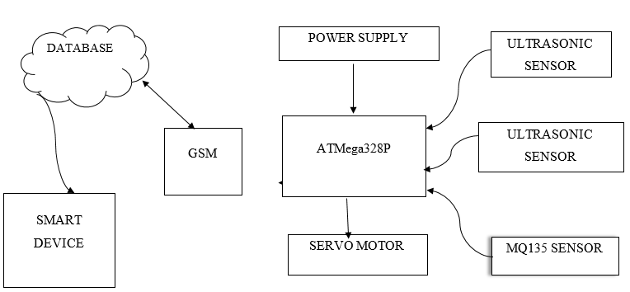

Figure 15. Block Diagram

## **3.1 GSM Module**

This module's primary function is to facilitate wireless communication between the smart waste bin system and the IoT web platform. Using the module's GPRS capability, the module is used to connect the hardware to the IoT platform. To avoid damage, the GSM module used in the project work is SIM800L, which operates with a voltage range of 3.4 – 4.4v. To avoid damage, a voltage divider is used to scale the voltage from the microcontrollers’ transmit line down before going to the module.



Figure 16. GSM setup

Using voltage divider rule:

----------------------------------------Eqn. 1

-----------------------------Eqn. 2

## **3.2 General Packet Radio Services**

General Packet Radio Services (GPRS) is a packet switching technology that allows data transfer over cellular networks. GSM's functionality is extended by GPRS.

**3.3 How The Gprs Work**

The GPRS integration enables the device to connect wirelessly to the web or internet from any location using the means provided (in this case the internet access is provided by SIM card).

As a result, alert system signals or information update the database via GPRS. The benefit of GPRS is that it is not always actively connected, so it can be described as passively connected. When there is a signal, it becomes active. As a result, energy is being used efficiently.

**3.4 Ultrasonic Sensor**

The capability of the ultrasonic sensor is used to monitor the level of waste in the bin as well as detect human presence approaching the waste bin. The sensor is linked to the microcontroller, and the sensor's readings are used to update the web page via GSM (GPRS). It all starts with a pulse on the Trigger pin that is at least 10 S (10 microseconds) long. In response, the sensor sends an eight-pulse sonic burst at 40 KHz. This 8-pulse pattern distinguishes the device's "ultrasonic signature," allowing the receiver to distinguish the transmitted pattern from ambient ultrasonic noise.

The eight ultrasonic pulses leave the transmitter by traveling through the air. Meanwhile, the Echo pin is set to HIGH to initiate the echo-back signal.

If those pulses are not returned, the Echo signal will timeout after 38 mS (38 milliseconds) and return low. As a result, a 38 mS pulse indicates that there is no obstruction within the sensor's range.

If the reflected pulses are received, the Echo pin goes low as soon as the signal is received. This results in a pulse with a width ranging from 150 S to 25 mS, depending on how long it took for the signal to be received.

The received pulse's width is then used to calculate the distance to the reflected object. A simple distance-speed-time equation can be used to calculate this.

Distance = 1/2(Speed x Time)

**3.5 MQ135 Sensor**

The web platform is being updated using MQ135's ability to detect foul odors in the environment. Holding the gas sensor near the smoke/gas that it should detect and turning the potentiometer until the Red LED on the module begins to glow is how the gas sensor is calibrated. To increase sensitivity, turn the screw clockwise, and to decrease sensitivity, turn it anticlockwise. The comparator on the module is constantly checking to see if the analog pin (A0) has reached the threshold value set by the potentiometer. When it crosses the threshold, the digital pin (D0) goes HIGH and the signal LED illuminates. This configuration is useful for instructing the microcontroller to perform an action when a certain threshold is reached. The microcontroller then sends data from the sensor to the web.

**3.6 Microcontroller**

The device's control unit is housed within this unit. It is in charge of the device's operation. It receives data from the sensing unit, processes it, and transmits the result to the database via GSM.



Figure 17. ATMEGA328P setup

**3.7 Cloud/Web Application**

The GSM module's GPRS capability is used to transfer data from the GSM module to the web-based application. The diagram below depicts the data movement diagram, which describes the movement of data across the entire system, from the electronic device to the web platform and back.



Figure 18. Web movement diagram

## **3.8 Flowchart of the system.**

The flowchart of the system shows the flow of information and procedure in the Smart waste bin management system

The system starts when it is powered on, it then proceeds to check for human presence at a set range, if it doesn't detect the presence of a human being, it continues its check till it does.

In the event that it detects the presence of a human being, the waste bin opens for the human being to dispose their waste. When waste disposal has been done, the system checks if human presence is out of range, then proceeds to close.

The system carries out a continuous concurrent check to ascertain whether the level and dirt of waste has reached a certain alarming level. If it reaches that certain level, it sends a prompt to the website.

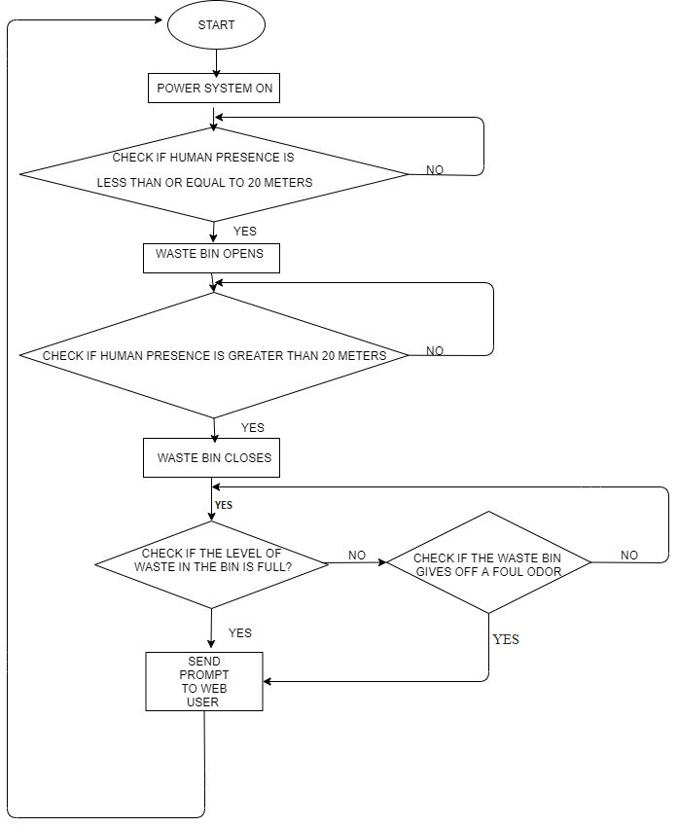

Figure 19. Flowchart of the system

### **3.8.2 Program Structure**

The Smart Bin Application is composed of three blocks. A frontend user application, a backend socket server, and a database are all required. React was used to build the frontend application. Js contains the UI components with which the end user interacts. The user can see the state of the bin here: The amount of dirt in it, as well as a warning to indicate the presence of foul odors. The user can also change his credentials in the app's settings section.

The Node.Js-based backend server consists of an HTTP server that handles all data requests from the hardware device and a Socket server that sends the updated state of the waste bin to the frontend interface in realtime. This server's job is divided into three major parts. It:

* Sends data and serves the UI component to the user.
* Receives data from the Waste Bin through HTTP calls.
* Connects to the database and stores all recorded state of the waste bin.

MongoDB is the database system used here; it is a NoSQL database that stores all received data in flexible, JSON-like documents, which means that fields can vary from document to document and data structure can change over time. It is directly connected to the Node.Js server and is used to save the dirt level as received from the sensor as well as a two-state variable representing the presence or absence of foul odor. MongoDB is popular due to its simple data structuring mechanism and ease of storing and retrieving data.

The diagram below shows how the three blocks that make up the system are connected.

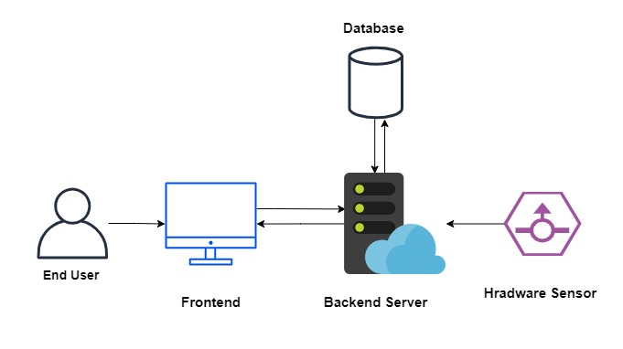

Figure 20. Web Interaction

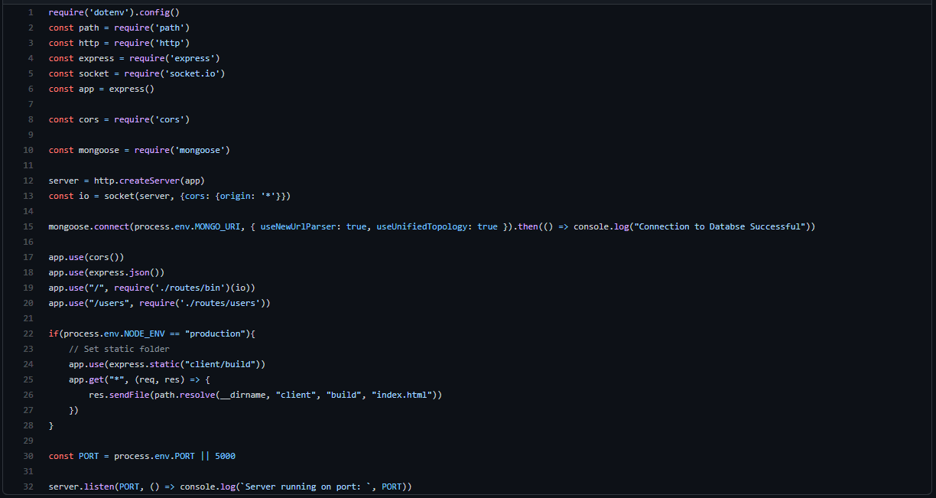

Figure 21-Backend code

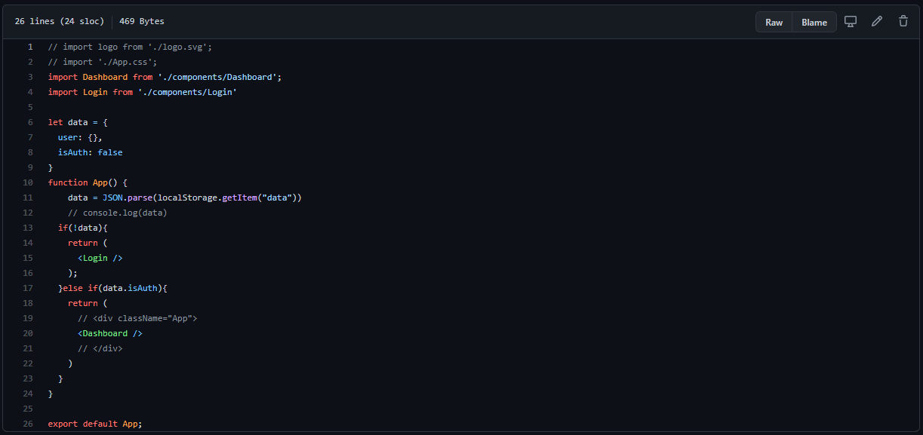

Figure 22. Front end code

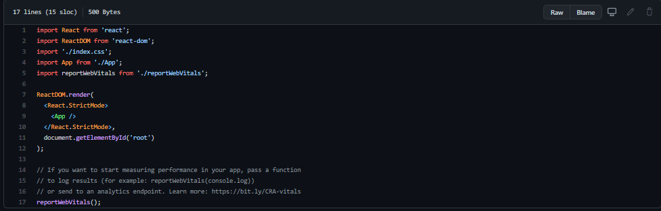

Figure 23. index code



Figure 24. dashboard code



Figure 25. Login Page code

## **3.9 Construction and Packaging**

The circuit was designed with proteus simulation software, implemented with a Veroboard, code was written with Arduino IDE, and the hex file was dumped into the Atmega328p microcontroller with the TL866 universal programmer.

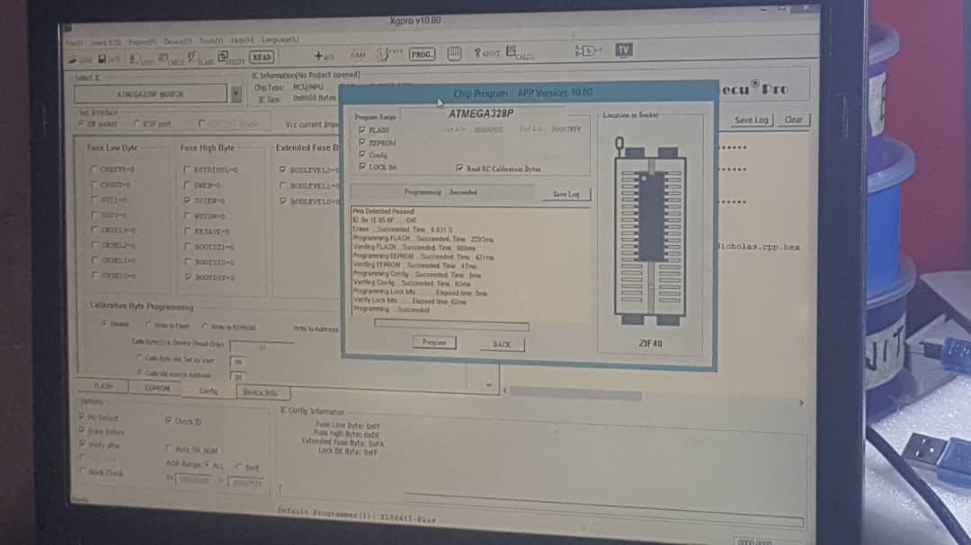

Figure 26. Universal programmer

## **3.9.1 Construction Techniques**

During the implementation of this project, the following procedures were properly considered,

1. Purchasing of all necessary materials and components
2. Checking the purchased components with an ohmmeter before making the necessary connections with the components
3. Making a schematic diagram or arranging the materials/components
4. Testing the finished system to see if the design is functional and
5. Finally, the project's design will be implemented.

After gathering all of the necessary materials, I began designing the circuit diagram, which was followed by the assembly of the components onto the Vero board, and finally by the proper soldering of the components. After all of the components were soldered onto the board, it was properly confirmed that it was complete.

The construction was done in stages, beginning with circuit setup on a project board to test the design's feasibility and to determine which stages may require adjustment due to component tolerance effects that may cause some deviation from expected performance. As a result, the construction was done in stages because it is more convenient to assemble large systems or circuits in stages from independent modules.

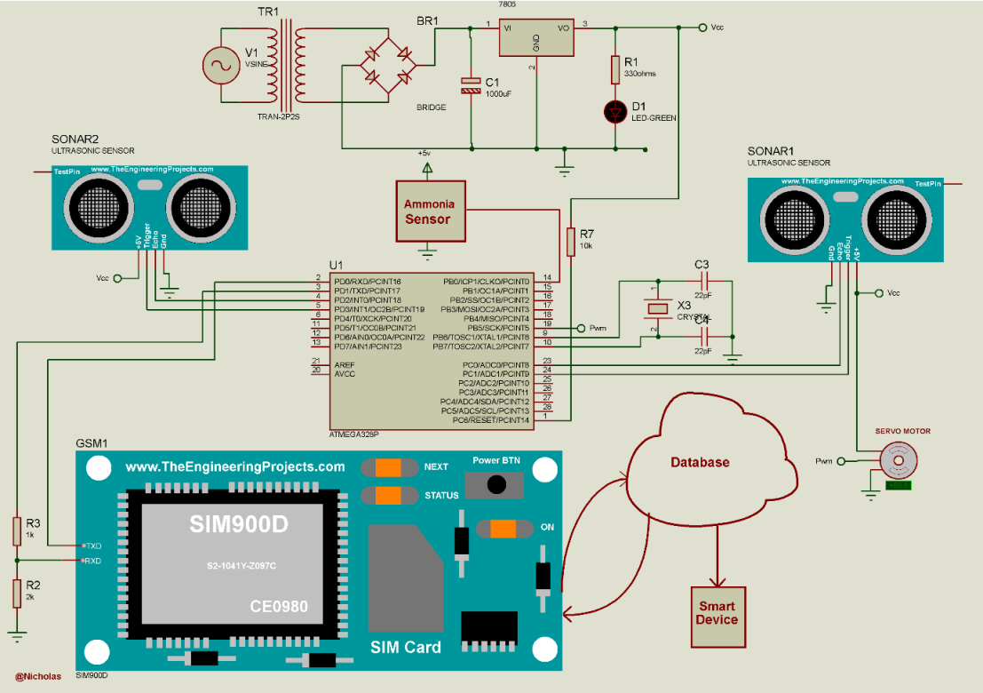

Figure 27. Circuit Diagram

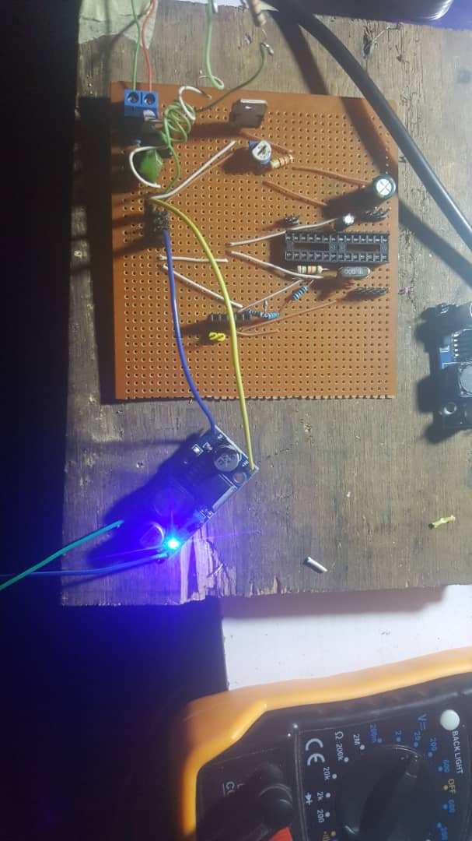

Figure 28. Circuit on Vero board

## **Materials/Components Used In The Construction**

The components used in the construction of this project are listed below.

* Soldering iron
* Soldering Lead
* Digital multimeter
* Hand drilling machine
* Vero board
* Jumper wires
* Bread board
* Screw driver
* File
* Sandpaper
* Soldering lead
* Universal programmer
* Laptop
* De-soldering pump.

## **Casing and Packaging Material**

This section refers to the product's enclosure and protective features. To avoid electrocution, the electronic component's packaging must be properly embedded, and drastic measures must be taken to cover its construction. Electronic system packaging must also consider mechanical damage protection.

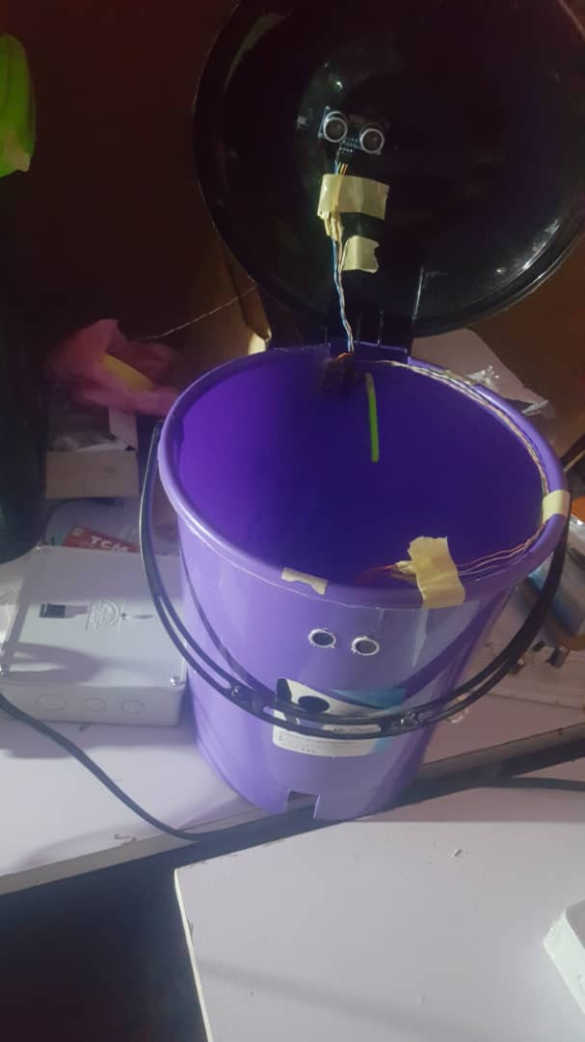

Figure 29. Packaged system

# CHAPTER 4

# TESTING AND RESULT

## **4.1 TESTING**

The system test stage checks that the system functions correctly and meets all the requirements identified in the analysis stage. The IOT intelligent waste monitoring system were tested below following:

1. Functionality Testing

2. Performance Testing

3. User Acceptance Testing

4. Application Testing

### **4.1.1 Functionality Testing**

Functionality testing ensures that the project performs and functions correctly in accordance with the design specifications. We check the web's core application functions, the sensors' response to stimulus, connectivity, and installation during functionality testing. Functionality testing ensures that a project remains fully operational after deployment.

### **4.1.2 Performance Testing**

Performance testing aids in the development of higher-quality software in less time and at a lower cost. The goal is to test performance early and frequently during the development process, as well as to test functionality and performance simultaneously. This is due to the fact that the longer you wait to conduct performance tests, the more expensive it will be to implement changes.

### **4.1.3 User Acceptance Testing**

User Acceptance Testing (UAT) is a formal testing of user needs, requirements, and business processes to determine whether or not a system meets the acceptance criteria and to allow the user, customers, or other authorized entity to decide whether or not to accept the system. We already know what kind of feature is being tested by the user and what the user's expectations are in User Acceptance Test. Vroomans (2014)

### **4.1.4 Application Testing**

The researcher of this project tested the first release of the IoT smart waste bin monitoring system. Testing was carried out in order to obtain feedback on how the actual system functions.

The circuit was design using proteus simulation software, the design was implemented using a breadboard and finally transferred to a Veroboard, the code was written using Arduino IDE and hex file dumped into the Atmega328p microcontroller using TL866 universal programmer.

## **4.2 TESTING SCREENSHOTS**

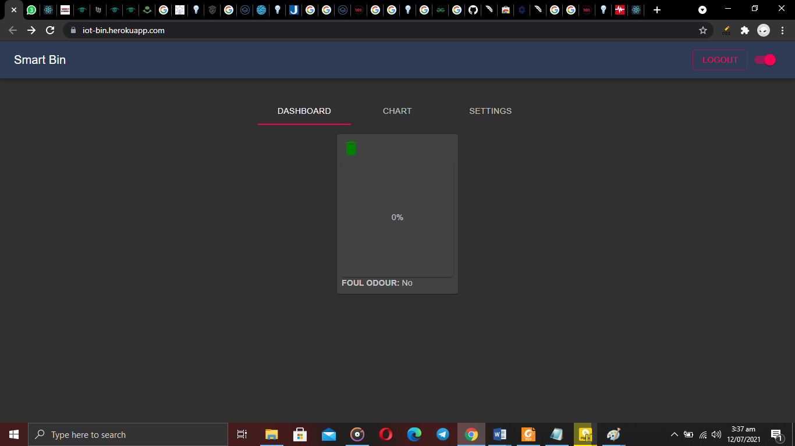

Figure 30. System at 0% waste

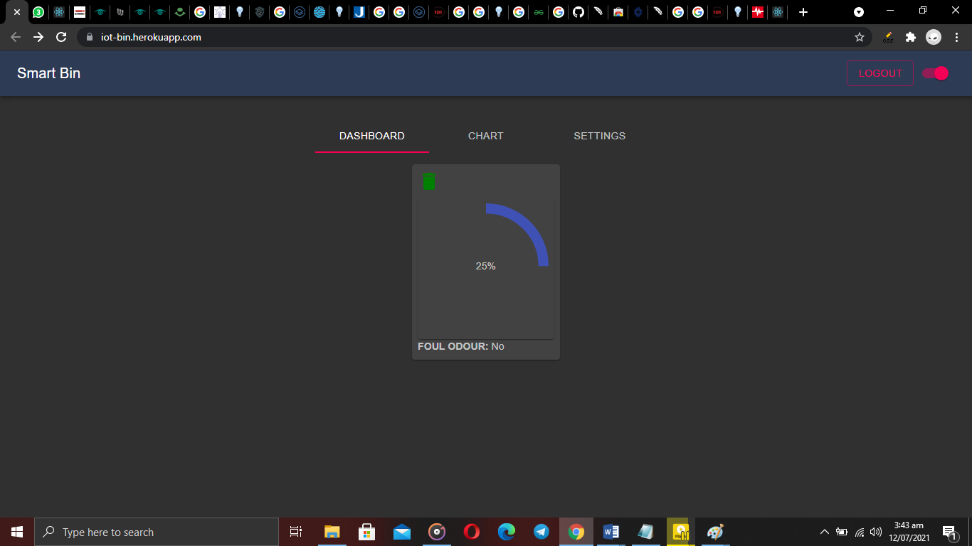

Figure 31. System at 25% waste

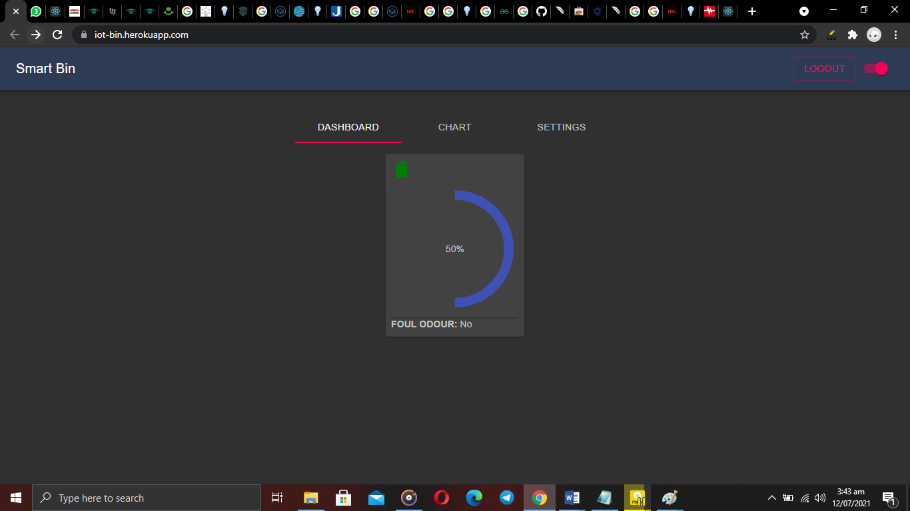

Figure 32. System at 50% waste

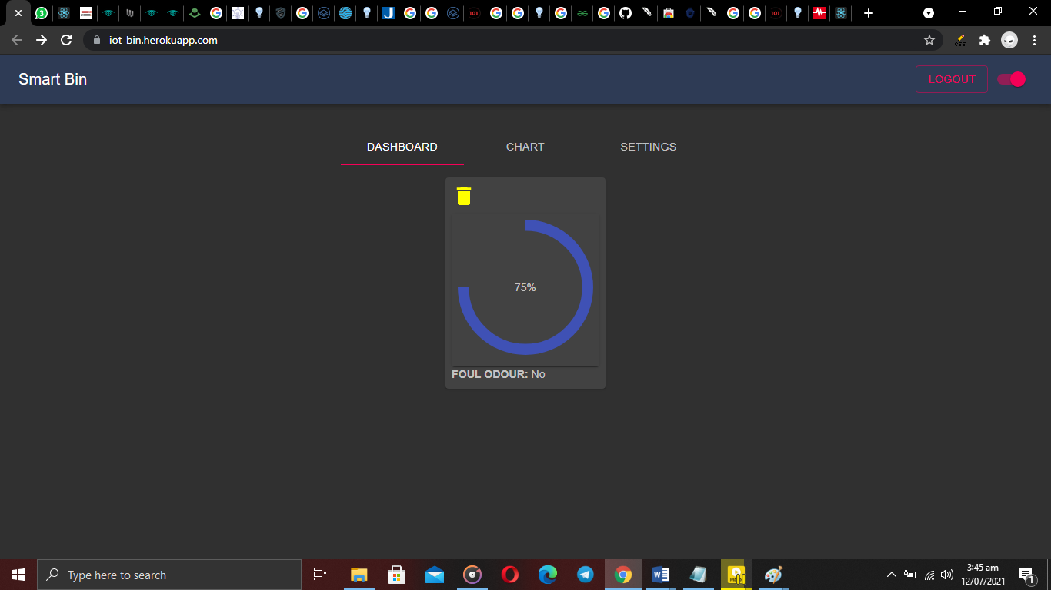

Figure 33. System at 75% waste

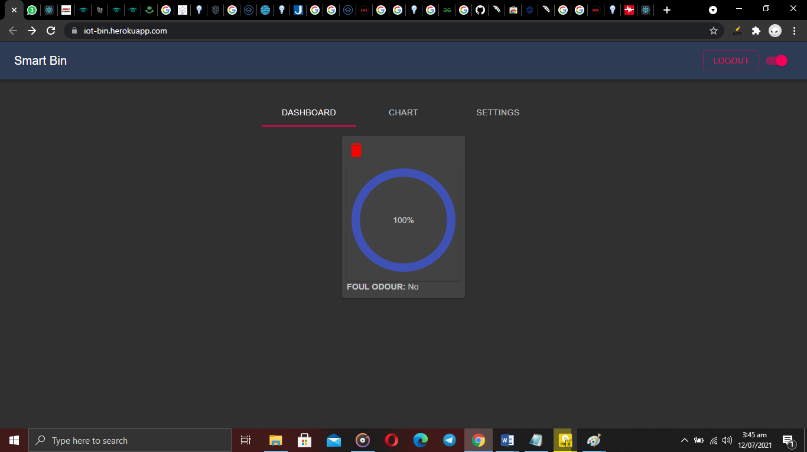

Figure 34. System at 100% waste



Figure 35. System showing foul odor detected

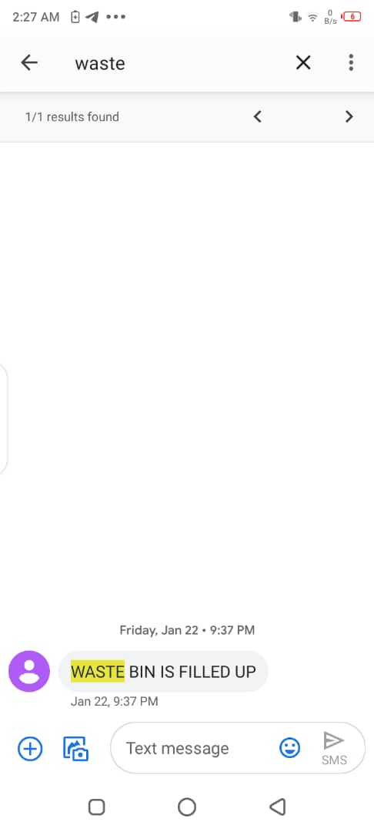

Figure 36. Alert from web platform

## **4.3 RESULT**

At the end of this work, the system effectively

* Detects the level of waste in the waste bin
* Detects the smell in the waste bin
* Sends the data gathered by the microcontroller from the various sensors to the web platform using the GSM(GPRS) module
* Sends alerts to the end users notifying them of its state

## **4.2 BILL OF ENGINEERING MEASUREMENT AND EVALUATION (BEME).**

Table 3. bill of engineering measurement and evaluation (beme).

|  |  |  |  |  |
| --- | --- | --- | --- | --- |
| **S/N** | **COMPONENTS** | **QUANTITY** | **UNIT**  **PRICE(N)** | **TOTAL**  **PRICE(N)** |
| 1. | Microcontroller | 1 | 2,000 | 2,000 |
| 2. | Ultrasonic Sensor | 2 | 2,000 | 4,000 |
| 3. | MQ135 | 1 | 1,500 | 1,500 |
| 4. | Servo Motor | 1 | 3,000 | 3,000 |
| 5. | Transistor | 2 | 50 | 100 |
| 6. | Voltage Regulator | 2 | 80 | 160 |
| 7. | Capacitor | 5 | 50 | 250 |
| 8. | Resistor | 10 | 10 | 100 |
| 9. | GSM Module | 1 | 2,000 | 2,000 |
| 10. | Waste Bin | 1 | 5,000 | 5,000 |
| 11. | Server Hosting Service | 1 | 10,000 | 10,000 |
| 12. | Crystal | 1 | 150 | 150 |
| 13. | Jumper Wire | 5 yards | 100 | 500 |
| 14. | Battery (6 Volts) | 2 | 900 | 1,800 |
| 15. | Diode | 2 | 20 | 40 |
| 16. | Adapter | 1 | 800 | 800 |
| 17. | DC DC Converter | 1 | 1,500 | 1,500 |
| 18. | Vero board | 1 | 300 | 300 |
| Total | | | | 33,200 |

# CHAPTER 5

# CONCUSION AND RECOMMENDATION

## **5.1 CONCLUSION**

The goal of this project was to create a smart waste monitoring system using internet of things technology in the most efficient and practical way possible, and the goals were met using the best approach possible. The system achieves this with an efficiency rate of 80%. This project will be very useful to individuals and waste companies who have always had problems with waste disposal. The incorporation of IoT into the waste management process is the foundation for addressing Nigeria's widespread pollution problem. It also results in a higher and more efficient work rate for waste disposal services. It will also encourage users of alternative waste disposal systems to purchase and use these systems, which provide a cleaner and smarter source of waste disposal that is safer for the environment.

## **5.2 RECOMMENDATION**

In order to increase the accuracy of the proposed system, the following can be done

* The system should be implemented with a GPS so the actual location of the waste bin can be detected
* The system should be built with a database to store data and map patterns on areas that have their waste bins full always

# REFRENCES

Callum McClelland,” Introduction to the internet of things”, 2 July 2020.

David Blain, “What is Internet of things”, 13 May 2019. Retrieved from https://internetofthingsagenda.techtarget.com/definition/IoT-device

David Pascal, “Applications of GSM module”, 21 Feb 2018. Retrieved from https://www.elprocus.com/gsm-technology-architecture-its-applications/

David Pascal, “GSM/GPRS Module”, 14 June 2019. Retrieved from https://www.electronicshub.org/gsm-gprs-module/

Dunn Jared, “Servo motor working principle”, 23 May 2019. Retrieved from https://www.jameco.com/Jameco/workshop/Howitworks/how-servo-motors-work.html

Jamal Lascelle, “Introduction to ultrasonic sensors”, 13 July 2020. Retrieved from https://www.maxbotix.com/articles/how-ultrasonic-sensors-work.htm#:~:text=Ultrasonic%20sensors%20work%20by%20sending,and%20to%20receive%20the%20echo.

James C. Whitaker, “IoT basis- A guide for beginners”, 21 May 2019. Retrieved from https://whatis.techtarget.com/feature/IoT-basics-A-guide-for-beginners

Kavya M., Sahana P., Shruthi G., Sunitha M. C., Jyothi A P.” SENSOR BASED SMART  
DUSTBIN FOR WASTE SEGREGATION AND STATUS ALERT”, March 2017.

Kelly Price, “The working principle of an alcohol sensor”, 13 August 2017. Retrieved from https://www.elprocus.com/mq-135-alcohol-sensor-circuit-and-working/

Liam Vale, “Servo motors working principles”, 28 August 2020. Retrieved from https://circuitdigest.com/article/servo-motor-working-and-basics

Liam Vale, “Servo motors”, 13 August 2020. Retrieved from https://www.elprocus.com/servo-motor/

Lilian D. Raul, “Principles of GSM”, 13 August 2017. Retrieved from https://www.electricaltechnology.org/2018/01/gsm-global-system-mobile-communications.html

Lucy Lu, Jasper Kidd, “Atmega382p description”. Retrieved from https://components101.com/microcontrollers/atmega328p-pinout-features-datasheet

Maher Arebey, M. A. Hannan, Hassan Basri, Huda Abdullah,” Solid Waste Monitoring and  
Management using RFID, GIS and GSM”, June 2019.

Md. Aasim Anwar, Prateek Sarkar, Rajeshwar Dutta, Md. Sadik Mohammad Mollick,” IOT  
BASED GARBAGE MONITORING USING ARDUINO”, May 2018.

Michael E., Otaru C. O., Liman A. D., Bomoi M. I., Awotoye B.,” Design and Development  
of a Smart Waste Bin”, October 2017.

Paul Grisham, “MQ2 connections with arduino nano”, 8 June 2020. Retrieved from https://lastminuteengineers.com/mq2-gas-senser-arduino-tutorial/

Prof. S.A. Mahajan, Akshay Kokane, Apoorva Shewale, Mrunaya Shinde, Shivani Ingale,”  
Smart Waste Management System using IoT”, April 2017.

Rajul Sahit, “The Working principle of GSM module”, 13 January 2021. Retrieved from https://www.electricaltechnology.org/2018/01/gsm-global-system-mobile-communications.html

Ricardo Nugent, “ATMEGA382P compatible systems”, 17 August 2016. Retrieved from https://engineering.eckovation.com/arduino-architecture-explained/

Sarah Presley, “Internet of things, a soft dive into the new wave”, 2 August 2019. Retrieved from https://www.wired.com/story/wired-guide-internet-of-things/

Shubhangi Thorat, Swati Kanase, Pooja Bhingardeve, “SMART DUSTBIN CONTAINER  
USING IOT NOTIFICATION”, 03 March 2019.

Shwetashree Vijay, Sam Raju, Pilla Nitish Kumar, Vivekanandan S.,” Smart Waste  
Management System using ARDUINO”, December 2019.

# APPENDIX

## **META ANALYSIS TABLE**

|  |  |  |  |  |  |
| --- | --- | --- | --- | --- | --- |
| S/N | AUTHOR | YEAR | TITLE | IMPORTANCE | LIMITATION |
| 1 | Michael E., Otaru C. O., Liman A. D., Bomoi M. I., Awotoye B. | 2017 | Design and Development of a Smart Waste Bin | This paper shows a smart waste bin created using Arduino Uno as it’s microcontroller, and a Passive Infrared sensor (PIR) to detect the heat signals of a human in order for the waste bins lid to open or close. | This work only incorporates technology that shows how the lid opens and closes. Thereby leaving it at a gross disadvantage of actually knowing the level of waste in the bin and controlling the disposal of waste using IoT capabilities. |
| 2 | Kavya M., Sahana P., Shruthi G., Sunitha M. C., Jyothi A P. | 2017 | Sensor Based Smart Dustbin For Waste Segregation And Status Alert | This paper details the use of the ARM microcontroller and various sensors to effectively sort out the different waste that are being thrown into the waste bin, and helps the trash collector with recycling process. It shows a real time technique where the system with the aid of sensors like IR, Moisture and Metal sensor is able to detect each garbage thrown in it. When the trash can is filled, the system sends a ping to the phones of the trash collection companies and alerts them of its status using GSM module. | The shortcomings of this system is that it has no real time monitoring platform, thereby making it impossible for the end user and the trash collection agencies be updated. |
| 3 | Shwetashree Vijay, Sam Raju, Pilla Nitish Kumar, Vivekanandan S. | 2019 | Smart Waste Management System using ARDUINO | Here an automated system is provided for segregating wet and dry waste. The system makes use of Arduino as it’s microcontroller. The system basically uses sensors like the IR sensor, Moisture sensor and ultrasonic sensor to achieve this. The system uses IR sensor to detect the presence either wet or dry waste, while the moisture sensor is used to detect the presence of wet waste. The ultrasonic sensor is used to measure the distance of the container to the lid. When the system detects only readings from the IR sensor, the rotor spins towards the dry waste section, when it detects reading from both the IR sensor and the moisture | The limitation to this work include, its inability to notify the user in a case where it is overwhelmed with waste, i.e. it lacks real time monitoring system |

## **CODE SNIPPETS**



Figure 37. Dashboard Code



Figure 38. Login Code



Figure 39. Setup Code

All other codes can be obtained from the following git repository

<https://github.com/edwardoboh/smart-bin.git>